EXTERNAL CORROSION CHARACTERIZATION OF A BURIED NICKEL PLATED AISI 1015 STEEL PIPES IN OIL AND GAS ENVIRONMENT

SUBMITTED TO

DEPARTMENT OF MECHANICAL ENGINEERING,

FACULTY OF TECHNOLOGY,

UNIVERSITY OF IBADAN, IBADAN

BY

**OLADIPO, BOLAJI AHMED**

**145517**

IN PARTIAL FULFILLMENT OF THE REQUIREMENTS FOR THE AWARD OF BACHELOR OF SCIENCE MECHANICAL ENGINEERING OF THE UNIVERSITY OF IBADAN

Engr. O. O. E.Ajide

B. Sc (Ife), M.Sc (UI), MNIMechE, MNSE, COREN Regd

PROJECT SUPERVISOR

MARCH, 2014.

# ABSTRACT

One of the serious problems of oil extracting industry is the corrosion process (Abd El-Lateef, 2012). A drawn out preliminary conclusion form the reviewed literatures submits that corrosion still remains one of the major drawback issues in the oil and gas industry. By reason of this, optimal characterization of corrosion resistant materials is of paramount essentiality.

The Methodology followed that the experiment was carried out in a simulated oil and gas environment using the weight loss analysis for the determination of corrosion penetration rate (CPR). Modified Artificial Neural Network (MANN) in MATLAB R2009a was afterwards used in clarifying the pattern of the corrosion effect together with the interpretation of the derived process algorithm for the analysis and for generating expected results through compilation and execution of the codes. The reason for adopting this software is as a result of its capabilities and unmatched uses.

After the whole experimental processes, micrograph microstructures of the corroded specimens where taken to visually describe their corrosion penetration rate. Interpretations from the Modified Artificial Neural Network algorithms, results and graphs was then used to accurately determine the corrosion penetration rate as affected by the varied input parameters (soil sample temperature, immediate surrounding temperature and the soil sample pH).

In conclusion, Modified Artificial Neural Network relationships between the varied selected input parameters that affects corrosion rate (soil sample temperature, immediate surrounding temperature and pH value) and the output parameter (Corrosion Penetration Rate) were achieve.

# ACKNOWLEDGEMENT

To the one that saw me through all the ups and downs of this project and made me accomplish the tasks excellently, I give the entire acknowledgement to God almighty.

I appreciate the tireless support and guidance of my able project supervisor, the person of Engr. O. O. E. Ajide B. Sc (Ife), M.Sc (UI), MNIMechE, MNSE, COREN Regd. He is the best project supervisor ever.

Also, I appreciate my mother, Mrs Funmilayo Oladipo, a strong and true mother. I would not be mincing words if I had said that she did this whole project single headedly. I love you. May you eat the fruit of your labour.

My gratitude also goes to Mr. Ilobekemen Aikigbe and all his extended family members for their selfless contributions to the success of this project. My journey to the Niger Delta and all that I achieve would not have been possible without you.

I also appreciate all my sisters for their love. I believe it is such a rare privilege to have you. Aunty Nike (Big mummy), Aunty Kemi (Iya Noah), Aunty Seyi. May God bless you all.

I will not conclude this without appreciating everyone of my friend and colleague in their contributions in one way or the other. Chukwuka Monyei, Samuel Osho, Abisola Otesile, Oyedele Joseph and every other person that space might not permit to include. Sincerely, I appreciate you all. May God bless you all.

# CERTIFICATION

This is to certify that the project report entitled; ‘**External Corrosion Characterization of a Buried Nickel Plated AISI 1015 Steel Pipes in Oil and Gas Environment**’ is a record of work carried out by BOLAJI AHMED OLADIPO with matriculation number 145517 and submitted in partial fulfilment of the requirements for the award of the degree of Bachelor of Science (B.Sc) in Mechanical Engineering, Faculty of Technology, University of Ibadan, Ibadan.

------------------------------------------------

SUPERVISOR

**Engr. O. O. E. Ajide**

B. Sc (Ife), M.Sc (UI), MNIMechE, MNSE, COREN Regd.

----------------------------------------------------

Ag. Head, Department of Mechanical Engineering

**Dr. A.A. Dare**

B.Sc, M.Sc, Ph.D (Ibadan), MNSE ,COREN Regd.

# DEDICATION

This project is dedicated to my mother, Mrs Funmilayo Oladipo.

**TABLE OF CONTENTS**

ABSTRACT i

ACKNOWLEDGEMENT ii

CERTIFICATION iii

DEDICATION iv

CHAPTER 1 1

INTRODUCTION 1

1.1 Background to the study 1

1.2 Statement of Problems 2

1.3 Objectives of the study 3

1.4 Scope of Study 3

1.5 Justification/Motivation 3

1.6 Expected Contributions 3

1.7 Expected Conclusion 4

**CHAPTER 2** 5

**LITERATURE REVIEW** 5

**2.1** **Historical background** 5

**2.2**  **Review of related literature** 5

CHAPTER 3 10

METHODOLOGY 10

3.1 Introduction 10

3.2 Acquisition of the core materials used 10

3.2.1 Material 1: AISI 1015 steel pipe 10

3.2.2 Material 2: Soil samples 11

3.2.3 Material 3: Crude oil 11

3.3 Preparation of the AISI 1015 steel material for the burial 12

3.3.1 Cut out the required sections 12

3.3.2 Nickel electroplating of 5 of the cut out specimens 13

3.3.3 Cleaning of the remaining 5 non-electroplated cut out specimens 15

3.4 Parameters collected and instruments 15

3.4.1 Soil samples temperatures 15

3.4.2 Immediate surroundings temperatures 15

3.4.3 pH values 15

3.4.4 Weight loss 16

3.5 Procedure taken for the experimentation processes; simulation of typical oil and gas condition for the steel burial and the artificial neural network modelling. 16

3.5.1 Simulation of typical oil and gas condition for the steel burial 16

3.5.2 Analysis using Modified Artificial Neural Network (MANN) 19

DATA PRESENTATION, ANALYSIS AND DISCUSSION 29

4.1 Data Presentation 29

4.2 Graphical representation of the modified artificial neural network results 32

4.3 Microstructural metallographic examination 36

CHAPTER 5 43

CONCLUSIONS AND RECOMMENDATIONS 43

5.1 Conclusion 43

5.2 Recommendation 43

APPENDIX 44

REFERENCE 59

TABLE OF FIGURES

Figure 1: Picture of the cut-out specimen 12

Figure 2: Dimensioned schematic of the specimen 13

Figure 3: Arrangement of the whole set-up in an open space 17

Figure 4: Shows taking of pH reading for Soil sample E, nickel-electroplated 18

Figure 6: Input and output for the neural network 21

Figure 7: Flow chart for the Modified Artificial Neural Network 21

Figure 1: CPR of specimens in soil sample 1 30

Figure 2: CPR of specimens in soil sample 2 30

Figure 3: CPR of specimens in soil sample 3 31

Figure 4: CPR of specimens in soil sample 4 31

Figure 5: CPR of specimens in soil sample 5 32

Figure 6: ANN graphical result for soil sample 1 (electroplated and non-electroplated) 33

Figure 7: ANN graphical result for soil sample 2 (electroplated and non-electroplated) 34

Figure 8: ANN graphical result for soil sample 4 (electroplated and non-electroplated) 34

Figure 9: ANN graphical result for soil sample 4 (electroplated and non-electroplated) 35

Figure 10: ANN graphical result for soil sample 5 (electroplated and non-electroplated) 35

Figure 11: Micrograph microstructure of the non-plated steel specimen in soil sample 1 37

Figure 12: Micrograph microstructure of the nickel-plated steel specimen in soil sample 1 37

Figure 13: Micrograph microstructure of the non-plated steel specimen in soil sample 2 38

Figure 14: Micrograph microstructure of the nickel-plated steel specimen in soil sample 2 38

Figure 15: Micrograph microstructure of the non-plated steel specimen in soil sample 3 39

Figure 16: Micrograph microstructure of the nickel-plated steel specimen in soil sample 3 39

Figure 17: Micrograph microstructure of the non-plated steel specimen in soil sample 4 40

Figure 18: Micrograph microstructure of the nickel-plated steel specimen in soil sample 4 40

Figure 19: Micrograph microstructure of the nickel-plated steel specimen in soil sample 5 41

Figure 20: Micrograph microstructure of the nickel-plated steel specimen in soil sample 5 41

LIST OF TABLES

Table 1: The percentage of the individual constituent element of the AISI 1015 steel; sourced form (CeBepCTanb), a Russian steel company. (Appendix 11)……………………………10

# CHAPTER 1

# INTRODUCTION

## 1.1 Background to the study

Corrosion is fundamentally a reaction between a metal and its environment. As such, it is a heterogeneous reaction between a fluid and a solid (Ekott, et al 2012). This reaction specifically applies to the gradual action of natural agents, such as air and moisture on the metals.

The most prominent example of corrosion is the rusting of iron and steel (an alloy of iron). A complex chemical reaction in which the metal combines with both oxygen in air and water to form hydrated iron oxide (Fe2O3). This oxide is a solid that retains the same general form as the metal from which it is formed but porous and somewhat bulkier, and it is relatively weak and brittle (Microsoft Student, 2009).

In commercial practice, alloy steels contain carbon and usually manganese with phosphorous and silicon in varying percentages. Alloy AISI 1015 is commonly available as cold-rolled steel. It is obtainable in form of round rod, square bar, and rectangle bar. It has a good combination of all of the typical traits of steel - strength, some ductility, and comparative ease of machining.

Most of these alloy steels found their usage in been buried whereas, pipelines buried beneath the earth are usually prone to external corrosion since the conditions for corrosion to have effects on these pipes are always present. The presence of chemical substances such as Chloride (Cl), Oxygen (O2), carbon dioxide (CO2) hydrogen sulphide (H2S), water and microbiological bacteria could cause severe corrosion problem depending on the pH values, temperature, pressure, materials flow rate and flow profile of the system (Oyewole, 2011)

Corrosion of metals has been known to be disastrous in industrial setup and even more so in the petroleum industry (Sadiku-Agboola, 2012). As a means of preventing this principal problem, electroplating is widely used to coat a metal with a thin layer of another metal. Nickel electroplating is therefore becoming an increasingly versatile process used for surface finishing processes that have a broad spectrum of end use that includes decorative, engineering and electro-forming applications. Of the various electrodeposited metals, nickel is one of the most often employed to increase the corrosion resistance or electrical conductivity of the underlying substrate (Sadiku-Agboola, et al 2012). Nickel plating for engineering purposes are usually from solutions that deposits pure nickel. Its most important property in engineering end use are in; general corrosion resistance, wear resistance, solderability and magnetic and other properties that may be relevant in specific applications.

## 1.2 Statement of Problems

The enormous financial loss and the problems of plant shut down, lost production, product loss, product contamination, fire accidents, loss of customer confidence and environmental degradation as a result of corrosion is a serious challenge facing Oil and Gas industry.

Transportation of crude oil, gas and processed petroleum products take place mostly in steel pipes. Several methods have been studied to alleviate the effect of external corrosion in buried steel pipelines e.g. cathode protection and control of amount of H2S in the pipes etc. but none was able to effectively tackle the effect of external corrosion on this pipes, hence the need to revise this unworthy challenge.

## 1.3 Objectives of the study

In the light of this, an interest has been aroused on the study to critically examine this effect of corrosion therefore; the hallmark aim of this study is to investigate the underground corrosion behaviour of Nickel plated AISI 1015 steel in oil and gas environment.

## Scope of Study

This investigation is focused mainly on the Nickel plated AISI 1015 steel pipes that are buried in the oil and gas environment. Since AISI 1015 steel pipe is the core material of the research work, corrosion analysis methods that will be used are:

1. Weight loss method
2. Artificial Neural Network (ANN) analysis

## 1.5 Justification/Motivation

For many year now, researcher world-wide have been working assiduously on a considerable conclusion on how to lessen the great financial loss and problems of plant shut-down, lost production, product loss, product contamination, fire accidents, loss of customer confidence and environmental degradation as a result of corrosion which is a challenge facing the Oil and Gas industry. With all of these stated shortcomings highlighted above, an enthusiasm for the mitigation and unmatchable improvement was ignited.

## 1.6 Expected Contributions

This project anticipates to supply convincing facts on the characterizations of Nickel plated AISI 1015 steel pipes that are buried. This work of study when accomplished successfully, would remarkably append to the reservoir of information that abounds in the world of oil and gas when it comes to corrosion study.

## 1.7 Expected Conclusion

After all the research and study is carried out, underground corrosion behaviour of Nickel plated AISI 1015 steel in oil and gas environment would have been critically characterised using the corrosion penetration rate (CPR) on an artificial neural network (ANN).

**CHAPTER 2**

**LITERATURE REVIEW**

**2.1 Historical background**

For thousands of years, pipelines have been constructed in various parts of the world to convey [water](http://www.britannica.com/EBchecked/topic/637296/water-supply-system) for drinking and irrigation. This includes ancient use of pipes in [China](http://www.britannica.com/EBchecked/topic/111803/China) made of hollow bamboo and the use of [aqueducts](http://www.britannica.com/EBchecked/topic/31132/aqueduct) by the Romans and Persians. The Chinese even used bamboo pipes to transmit [natural gas](http://www.britannica.com/EBchecked/topic/406163/natural-gas) to light their capital, [Peking](http://www.britannica.com/EBchecked/topic/448956/Beijing), as early as 400 BC. These have been a major use of pipes until a significant improvement of pipeline technology took place in the 18th century when cast-iron pipes were used commercially. The development of high-strength steel pipes thereafter made it possible to transport [natural gas](http://www.britannica.com/EBchecked/topic/406163/natural-gas) and [oil](http://www.britannica.com/EBchecked/topic/454269/petroleum) over long distances (Kennedy, 1993). By virtue of this, pipelines evolved to be the preferred mode of transportation for liquid and gas over other competing modes such as truck and rail for several reasons; they are less damaging to the environment, less susceptible to theft, and more economical, safe, convenient, and reliable than other modes.

Nowadays, there are hundreds of thousands of kilometres of pipelines in various sectors of industry, which include many uncoated pipelines in chemical manufacturing plants, interstate natural gas transmission lines, and offshore oil-and-gas production pipelines (Emami, 2011).

**2.2 Review of related literature**

Corrosion is fundamentally a chemical reaction between a metal and its environment. It may be caused by chemical reactions with carbonic acid, sulphuric acid or oxygen or by electrochemical metal ion transport (Ekott, 2012). This definition of corrosion given by Ekott above submits that by virtue of exposure of metals to the environment, corrosion is inevitable. This brought Emami (2012), to the conclusion that the annual cost of corrosion worldwide is over 3% of the world’s GDP. Even with this drawback, carbon steels have been on a wide application throughout the world. There are hundreds of thousands of kilometres of pipelines in various sectors of industry which include many uncoated pipelines in chemical manufacturing plants, interstate natural gas transmission lines, and offshore oil-and-gas production pipelines (Emami 2011).

But according to Oyewole (2011), the high demand for oil and gas is still on the increase and pipelines are recognized as the safest and most efficient way of transporting oil and gas and are mostly made of carbon steel. This does not help to alleviate the fact that corrosion still remains a major problem in the transportation of oil and gas from where they are produced to where they are needed of which, pipeline buried beneath the earth are more prone to external corrosion since the condition for corrosion to have effects on these pipes are always present. These conditions are the presence of chemical substances such as Chloride, Oxygen (02), carbon dioxide (C02) hydrogen sulphide (H2S), water. Microbiological bacteria could also cause severe corrosion problems depending on the pH values, temperature, pressure, materials flow rate and flow profile of the system (Oyewole 2011).

In this recent time, corrosion damages are not usually taken into consideration in the design and construction of some engineering systems, even when considered, unprecedented changes in the environment in which the structures operate can lead to unexpected corrosion damages. Ekott (2012) in the same vein thus highlighted that the failure of oil pipeline can be disastrous both to the environment and to the industry. This fact hitherto has therefore stirred a thirst in the minds of concerned researchers. Oyewole (2011) in his induced corrosion degradation study on gas pipeline system however established that the consequences of corrosion failures can be grouped into three broad categories;

1. Safety consequences
2. Environmental consequences
3. Business or economic consequences.

Under safety consequences, the problem of fatalities, injuries, fire and property damage that result from thermal radiation from fire fuelled from high pressure escaping fluid from the point of pipeline leak or rupture pipeline failure in the past have led to destruction of life and property.

Today, inferring from the insights of the concerned researchers, it can be affirmed that corrosion is no longer a new threat to the oil and gas industry. Several methods have been posited to alleviate the consequences that results from corrosion. One of the prominent methods recognized is electroplating. Electroplating is widely used to coat a metal, with a thin layer of another metal.

Oluranti et al (2011) discussed that nickel is one of the suitable materials for electroplating corrodible materials. He further explains that of the various electrodeposited metals, nickel is one of the most often employed to increase the corrosion resistance of underlying substrate and that the most important property of nickel in engineering end uses is generally corrosion resistance while concluding that 20% of nickel is consumed for engineering and electroforming proposes.

Emami (2011) however following the trend, also contributed to corrosion testing. He stated that the corrosion rate is measured by the reduction in weight of a material of known area over a fixed period of time which is accomplished by using the formula to determine the corrosion penetration rate. And it is expressed by the equation 1 below.

CPR (mm/y) = 87.6w/ρAt ….equation 1

ρ: Density, kg/m3

w: Mass loss in time, kg

t: Time, hours

A: Surface area, m2

Of course, after preparing the electroplated specimens, there is usually a need to device a method to characterize the effectiveness of the electroplating. Most researchers nowadays find modelling as a useful tool to this end. Emami (2011) describes one of the modelling tools as a means to solving real-world phenomena, investigate important questions about the observed world, explain real-world phenomena, test ideas and make predictions about the real world. The real world refers to; engineering, physics, physiology, ecology, wildlife management, chemistry, economics, sports and etc.

Having so many modelling tools to help interpret various daily activities, some tools have proven to be more versatile to the others. It is an incontestable fact that every human activity involves one mathematical problem or the other; the need to use mathematical modeling is increasing in modern times (Emami 2011). MATLAB is a mathematical modeling and numerical computing environment which is undoubtedly one of the most widely used tools for drawing out relationships between far unrelated patterns of parameters. It allows easy matrix manipulation, plotting of functions and data, implementation of algorithms, creating user interfaces and interfacing with programs in other languages. The Neural Network Toolbox present in MATLAB environment tools is used for designing, implementing, visualizing and simulating neural networks. It also provides comprehensive support for many proven network paradigms, as well as graphical user interfaces (GUIs) that enable the user to design and manage neural networks in a very simple way (http://www.mathworks.com/products/neuralnet).

Moreover, Artificial Neural Networks models have in general good performance even if one or more input parameters are unavailable. Lee and Kim (2009) have been capable of expressing a variety of non-linear surfaces using a number of input-output training patterns that are selected from the entire design space in a global manner. It gives us understanding into many real life processes and the interplay between or among variable(s) quantifying such models.

With all these argument, MATLAB with no doubt has placed at least a little confidence on researchers on the viability of employing Artificial Neural Network models in executing there modelling related studies and has instilled a hope in this study for comprehensive modeling and analysis.

# CHAPTER 3

# METHODOLOGY

## 3.1 Introduction

A drawn out preliminary conclusion form the reviewed literatures submits that corrosion still remains one of the major drawback issues in the oil and gas industry. By reason of this, optimal characterization of corrosion resistant materials is of paramount essentiality.

This Methodology study followed the use of weight loss analysis for the determination of corrosion penetration rate. Modified Artificial Neural Network (ANN) was afterwards used in clarifying the pattern of the corrosion effect together with the interpretation of the derived process algorithm for the analysis.

## 3.2 Acquisition of the core materials used

### 3.2.1 Material 1: AISI 1015 steel pipe

This is a pipe and its way bill containing the chemical compositions was gotten from the retailer, Ispat Steel Nigeria, Lagos. The table shown below is an extract of the way bill.

**Table 1: The percentage of the individual constituent element of the AISI 1015 steel; sourced form (CeBepCTanb), a Russian steel company. (Appendix 11)**

|  |  |
| --- | --- |
| Chemical composition of the alloy material (AISI 1015 Steel) in percentage | |
| Carbon | 0.139 |
| Silicon | 0.210 |
| Manganese | 0.49 |
| Phosphorous | 0.008 |
| Sulphur | 0.006 |
| Chromium | 0.09 |
| Nickel | 0.09 |
| Copper | 0.22 |
| Aluminium | 0.025 |
| N2 | 0.008 |
| Molybdenum | 0.008 |
| Vanadium | 0.002 |
| Carbon Equivalent Number | 0.26 |

### Material 2: Soil samples

These was gotten from the Niger Delta environment precisely Pan Ocean oil corporation, OvadeOgharefe. The soil samples were collected from five different locations on the on-shore flow station. These locations are:

1. Tank farm: This is a reservoir area where the crude oil is stored for a couple of hours. Gases are formed here and tap for further processes.
2. Skimmer pit: This is also a reservoir. The purpose is to allow separation of the produced water from crude oil.
3. Export pump: This is a custody transfer unit of the gas plant where transfer to bigger vessels for transportation is carried out.
4. Saver Pit: This a storage where the crude oil is kept before any further action is taken
5. Arrival manifold point: This is the area where the first on-land activity takes place. Here, the separator separates the crude oil into three major constituents which are oil, produced water and gas.

### Material 3: Crude oil

The crude oil used was obtained from Shell Petroleum Development Company, North bank flow station, Obotobol, Forcados, Delta state.

## Preparation of the AISI 1015 steel material for the burial

### Cut out the required sections

For this study, 10 cut-out specimens from the steel pipe were used. Each specimen part has a dimension of external diameter 60.8mm, thickness of 4mm and a height was 50mm. Below shows the picture of a the cut out specimen and a schematic with full dimensions.

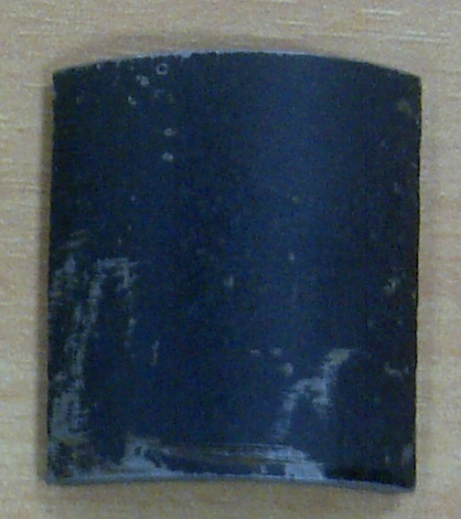

Figure 1: Picture of the cut-out specimen

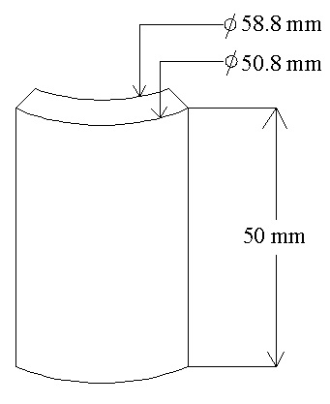

Figure 2: Dimensioned schematic of the specimen

### Nickel electroplating of 5 of the cut out specimens

The nickel electroplating was carried out at Federal Institute of Industrial Research, Oshodi (FIIRO). Five of the cut out specimens were electroplated since there were only five different soil samples used. Below is the nickel electroplating procedures followed:

1. Pickling: This is the removal of rust. The rust from the external surface of the specimen was removed by soaking it in concentrated Hydrochloric acid for about 2 -5 minutes. After which they were rinsed in water.
2. Polishing: This prepared the surface to be electroplated for better and even deposition of nickel. The polishing was carried out with a special grinding machine. After which they were smoothened on the buffering machine.
3. Electrolytic catalytic degreasing: This is the removal of oil/grease from the steel surfaces. The solution of the electrolyte was made of caustic soda, soda harsh and trisodium polyphosphate. Below is the summary of the electrolytic catalytic degreasing process parameters;

* Solution of electrolyte: Mainly Sodium Carbonate, Sodium hydroxide and Sodium ethacylicate.
* Sodium carbonate: 10.5g/litre
* Sodium hydroxide: 8.5g/litre
* Sodium ethacylicate: 10.5g/litre
* Temperature: 80 oC
* Time taken: 10 minutes

After all the pre-electroplating preparation processes were completed, the specimens were suspended into the nickel solution bath. Below is the summary of the electroplating process parameters;

* Solution of electrolyte: Mainly Boric acid, Nickel Sulphate and Nickel Chloride
* Boric acid: 35-50g/litre
* Nickel sulphate: 250-300g/litre
* Nickel Chloride: 40-55g/litre
* Nickel brightener: 0.5-0.8mil/litre
* Time taken: 25 min
* Temperature: 45 oC
* Voltage: 2.5 v
* Current: 50 A

### Cleaning of the remaining 5 non-electroplated cut out specimens

The cleaning of the remaining 5 cut out steel specimens was completed by pickling and rinsing with water. This was necessary so as to clean off the rust already present on the surfaces.

## Parameters collected and instruments

The data that were collected are soil sample temperatures, immediate surroundings temperatures and the pH values for 25 consecutive days.

### Soil samples temperatures

This is the temperature of the soil samples having the steel specimens buried in them. The activity was carried out at the burial site with a laboratory thermometer of calibration -10 oC to 110 oC. This was to allow for actual temperature of the set-up affected by the corrosion as temperature change affects the rate of corrosion of a substance.

### Immediate surroundings temperatures

This is the temperature of the immediate surroundings of the whole set-up. For a better and more precise modelling, this parameter was recorded. Also, a laboratory thermometer of calibration -10 oC to 110 oC was used and it was carried out on-site.

### pH values

From the reviewed literatures it was ascertained that the rate of corrosion is largely affected by the change in the pH values. This therefore made it highly required for it to be recorded from the experiment. Hanna brand pH metre of accuracy 0.1 was use. And the activity was carried out on site. At the first day, the pH meter was calibrated with a buffer solution of pH 4.0 then at the fourth day with a buffer solution of pH 10.0. This was necessary so as to allow for maximum accuracy of the pH metre. After taking all the pH readings, the soil minimum pH values for the non-electroplated and the electroplated specimens were 6.9 and 6.8 respectively while the maximum were 8.3 and 8.4. This conforms to the works of Oyewole (2011).

### Weight loss

Carrying out the weight loss check required a keen attention as the bulk essence of the experiment lies on it. For each day, after taking all other relevant readings, the steel specimens were removed from the soil samples, washed carefully with water, cleaned with neat wool material then taken to the laboratory for the weight loss. Sensitive digital weighing balance with an accuracy of 0.0001g was used.

## Procedure taken for the experimentation processes; simulation of typical oil and gas condition for the steel burial and the artificial neural network modelling.

### Simulation of typical oil and gas condition for the steel burial

10 small plastic containers of same size were filled with the 5 different soil samples gotten from the Niger Delta environment with 2 containers having the same soil samples.

5 of the electroplated steel samples were buried differently into 5 of the soil containers of different soil samples. The same procedure was carried for the other 5 non-electroplated soil samples.

Each soil sample shared in 2 containers and burying 1 electroplated steel in one with the other non-electroplated buried in the other. The plastic containers were labelled as illustrated below as shown also in figure 3 below:

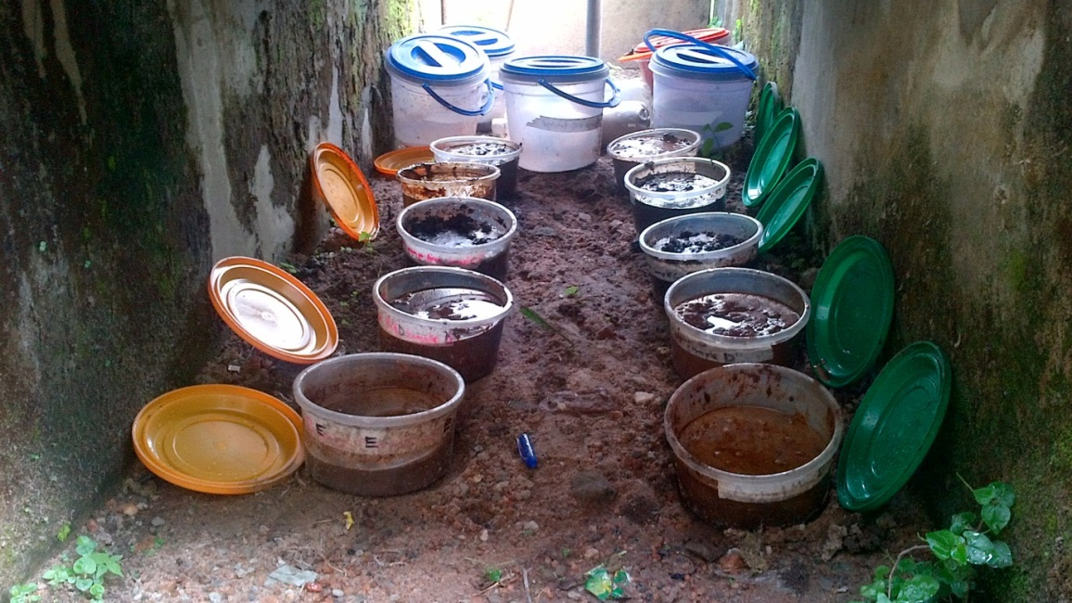

Figure 3: Arrangement of the whole set-up in an open space

* Sample 1: Tank farm soil sample (row 1)
* Sample 2: Skimmer pit soil sample (row 2)
* Sample 3: Export pump soil sample (row 3)
* Sample 4: Saver pit soil sample (row 4)
* Sample 5: Arrival manifold point soil sample (row 5)

In carrying out the experiment, the data were grouped into sets of input and output data. This is required so as to appropriately feed the modelling tool (Artificial Neural Network). The input data are:

* Temperature of the soil sample
* Temperature of the immediate surrounding
* pH of the soil sample

While the output data was:

* weight loss

The entire burial environment was arranged in an open space partly covered by a water tank at the department of Mechanical Engineering, Faculty of Technology, University of Ibadan. This is to simulate a real atmosphere for the experiment. The figure 3 above shows the set-up.

Explaining from figure 3 above, there are five rows of containers disregarding the bigger containers visible at their extreme, each row having two containers of the same soil sample. The different soil samples for the dual containers were listed above. It should also be noticed that there are two columns each column having five containers. The left column of containers contains the five different soil samples as listed at above with the nickel-plated cut-out specimens buried in them. Likewise the row the right, all the containers contain the five different soil samples but buried in them were the 1015 steel cut-out specimens.

All the three input parameters were taken at the burial site except for weight loss which was taken at the laboratory. The figure below shows the pH reading been collected at the soil sample 5 for the nickel-electroplated steel material with the digital pH meter.

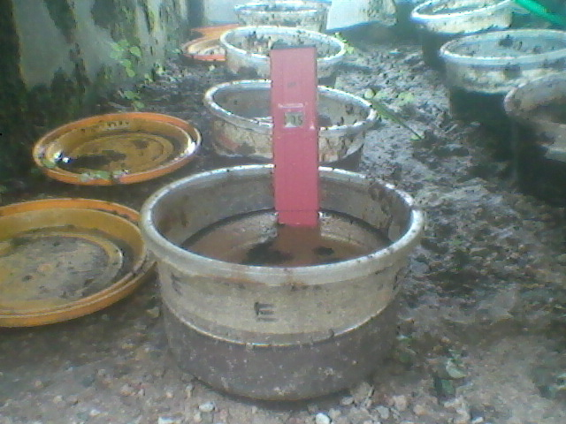

Figure 4: Shows taking of pH reading for Soil sample E, nickel-electroplated

### Analysis using Modified Artificial Neural Network (MANN)

#### Introduction

MATLAB R2009a was used extensively for generating expected results through compilation and execution of the codes. The reason for adopting this software is as a result of its capabilities and unmatched uses.

A function of MATLAB is ANN. As postulated by (Lee and Kim 2009), ANN is one of the most efficient ways of solving complex problems bit by bit. Also, as posited by (Lee and Kim, 2009), ANNs have the capacity to handle variety of non-linear surfaces using a number of input and output training patterns selected from the entire total field of possible data.

It was used in this study as a modelling tool on a series of seemingly unrelated input and output data collected to;

1. Train a pattern for the corrosion penetration rate
2. Investigate the effect of the input data in contribution to the corrosion penetration rate
3. Predict for outlying data accurately when computing in real life situations
4. Generate algorithms which could be used propose for possible results of the output (corrosion penetration rate) in the future when input data are varied
5. Plot graphs in various formats by manipulating data and executing simples codes

#### Training of the Modified Artificial Neural Network

The first task carried out on the modelling tool was training. Training in Artificial Neural Network is the process of exercising the modelling tool in order to allow it learns a particular pattern of behaviour before using it. The larger the number of data used for the training process, the more efficient and reliable the tool. This permits the tool to be able to handle a wide range of stochastic input data parameter efficiently. For this study, the whole 125 data collected for the 25 days was used for training the software.

#### Encoding in the Modified Artificial Neural Networks

As earlier stated in the previous chapter, the network requires input and output data. The input data are the data recorded which contribute to the corrosion penetration rate of the buried specimens while the output data is the data recorded which results from the effect of the various input parameters. The input data recorded are:

1. Soil sample temperature
2. Immediate surrounding temperature
3. pH value

While the output data recorded is:

1. Weight loss

The weight loss data recorded was afterwards translated to corrosion penetration rate. This was achieved by using the formula below as postulated by Emami (2011):

Where:

CPR: Corrosion penetration rate in (mm/y)

W: Weight of the buried material at instances in (g)

D: Density of the buried material in (g/cm3)

T: Time in (hrs)

In computing the various CPR(s) for the corresponding weight loss values, Microsoft excel was used extensively. The results displayed on the Microsoft excel were imported to the Matlab environment for further MANN analysis. This is due to the compatibility between the two computer softwares. The figure below shows the various input and output for the neural network.

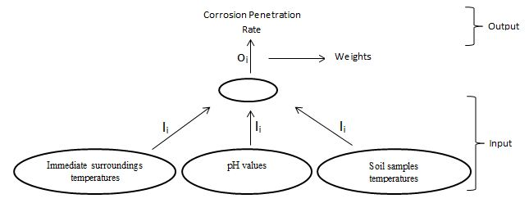

Figure 5: Input and output for the neural network

Dealing with neural networks, there are various encoding format. But for this study, the codes were developed newly. For this reason, the neural networks become modified thereby allowing for introduction of polynomial approximation (list square) format instead of the default neurons. The figure below shows the flow chart for the MANN.

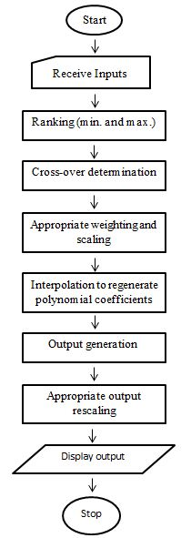

Figure 6: Flow chart for the Modified Artificial Neural Network

While modelling on the experiment on the MANN, four cases where considered. The cases are:

1. All the three inputs
2. The first two inputs only
3. The first and the last inputs only
4. The last two inputs only

Following the flow chart on figure 12 above, a sequential overview of the algorithm is however presented:

1. Start: This is a compilation initiation command.
2. Receive inputs: The input data received as been read from the Microsoft excel file saved in Matlab default folder are extracted into the Matlab memory.
3. Ranking: This is more of sorting out of the data. The first input which was the soil sample temperature was ranked. In respect of this, corresponding changes was applied across other input parameters which are immediate surroundings temperature and pH values and the output parameters.
4. Cross-over determination: This is the estimation of the number of turning points present in the output (corrosion penetration rate). For this analysis, the turning points were constrained to 2. This gave rise to a cubic polynomial equation (i.e. order 3). In the data used there are more than 2 turning points with the changes in the values not critically high. From this, a line of best fit was drawn while approximating by the lead square.
5. Appropriate weighting and scaling: Scaling was introduced so as to allow for convergence of all the data. This harmonises them to an approximately the same decimal fraction so they can relate well. This is appropriate because of the extreme nature of the values. Weighting on the other side tells the degree of contribution of an input over the other. But since the degree of contribution of the inputs had not been certified, they were all assumed to have the same relevance.
6. Interpolation to regenerate polynomial coefficient: This is the application of list square to establish a polynomial expression that generates a relationship between the CPR and all the inputs under consideration.
7. Output generation: The output computed.
8. Appropriate output rescaling: This recalled the scaling magnitude used earlier in step 5 and adjusted the output before displaying.
9. Stop: The computation ends

The transitions obtained from the output matrix are thus used in generating the order of the polynomial function. The first output is given as **K(I) = aI2 + bI + c.** The second input is modelled similarly which are used in generating the respective values of **a1**, **b1** and **c1**. The second output is thus given as **K(J) = a1J2 + b1J + c1.** The final output is therefore the average of this two values given as: **K = (K(I) + K(J)) / 2.**

**Baseline**

**K1  K2K3 K4**

**J1 J2J3 J4**

**I1  I2 I3 I4**

**Output**

**Inputs**

**Fig a: received inputs and output during training**

**J3 J1J4 J2**

**I3 I1 I4 I2**

**Ranked inputs**

**K3  K1 K4 K2**

**Ranked output**

**Fig b: ranked received inputs and output using baseline**

If

K1> K3

K1> K4  … (a)

K2< K4

Where Ii, Ji and Ki (i = 1, 2, 3, 4) are valid inputs and output respectively, then the number of cross overs could be determined from the ranked output

Two cross over signifies that the data could be modelled using a polynomial of order 3 (i.e. a cubic equation). In modelling therefore, the following equations are used:

n n

∑Ki = a*n + b∑Ii + c∑Ii2 ... (b)

i=1 i=1

n n n

∑KiIi = a∑Ii + b∑Ii2 + c∑Ii3  ... (c)

i=1 i=1 i=1

n n n

∑KiIi2 = a∑Ii2 + b∑Ii3 + c∑Ii4  … (d)

i=1 i=1 i=1

n n

∑Ki = a1*n + b1∑Ji + c1∑Ji2  … (e)

i=1 i=1

n n n

∑KiJi = a1∑Ji + b1∑Ji2 + c1∑Ji3  … (f)

i=1 i=1 i=1

n n n

∑KiJi2 = a1∑Ji2 + b1∑Ji3 + c1∑Ji4  … (g)

i=1 i=1 i=1

CASE 1

The corrosion penetration rate is determined by all the three contributing factors, the soil temperatures, the immediate surroundings temperatures and the pH values. These factors are appropriately scaled and uniformly (unity) weighted. The validity of this case scenarios would be based on its deviation from the standard calculated CPR.

In modelling the corrosion penetration rate under this case scenario, the following parameters are defined;

Let k be the number of inputs being considered

k = 3 … (1)

Highest order of polynomial, n, being considered is 3 … (2)

Let Wi be the respective weights for the inputs (soil temperatures, immediate surrounding temperatures and pH values)

Let Sfi be the respective scaling factor for each input considered

k

CPR = 0.33 * ∑ (ai+ bi*x, + ci*xi2 + di*xi3) … (3)

i = 1

Where ai, bi, ci and di are the respective constants for each respective input

bi= b *Sfi*Wi  … (4)

ci= c *Sfi*Wi  … (5)

di= d *Sfi*Wi … (6)

CASE 2

The corrosion penetration rate is determined by the first two contributing factors only, the soil temperatures and the immediate surroundings temperatures. These factors are appropriately scaled and uniformly (unity) weighted. The validity of this case scenarios would be based on its deviation from the standard calculated CPR.

In modelling the corrosion penetration rate under this case scenario, the following parameters are defined;

Let k be the number of inputs being considered

k = 2 … (7)

Highest order of polynomial, n, being considered is 3 … (8)

Let Wi be the respective weights for the inputs (soil temperatures and immediate surrounding temperatures)

Let Sfi be the respective scaling factor for each input considered

k

CPR = 0.50 * ∑ (ai+ bi*x, + ci*xi2 + di*xi3) … (9)

i = 1

Where ai, bi, ci and di are the respective constants for each respective input

bi= b *Sfi*Wi  …(10)

ci= c *Sfi*Wi  … (11)

di= d *Sfi*Wi … (12)

CASE 3

The corrosion penetration rate is determined by the first and the last contributing factors only, the soil temperatures and the pH values. These factors are appropriately scaled and uniformly (unity) weighted. The validity of this case scenarios would be based on its deviation from the standard calculated CPR.

In modelling the corrosion penetration rate under this case scenario, the following parameters are defined;

Let k be the number of inputs being considered

k = 2 … (13)

Highest order of polynomial, n, being considered is 3 … (14)

Let Wi be the respective weights for the inputs (soil temperatures and immediate surrounding temperatures)

Let Sfi be the respective scaling factor for each input considered

K = 2

CPR = 0.50 * ∑ (ai+ bi*x, + ci*xi2 + di*xi3) … (15)

i = 1

Where ai, bi, ci and di are the respective constants for each respective input

bi= b *Sfi*Wi  … (16)

ci= c *Sfi*Wi  … (17)

di= d *Sfi*Wi … (18)

CASE 4

The corrosion penetration rate is determined by the last two contributing factors, the immediate surroundings temperatures and the pH values. These factors are appropriately scaled and uniformly (unity) weighted. The validity of this case scenarios would be based on its deviation from the standard calculated CPR.

In modelling the corrosion penetration rate under this case scenario, the following parameters are defined;

Let k be the number of inputs being considered

k = 2 … (19)

Highest order of polynomial, n, being considered is 3 … (20)

Let Wi be the respective weights for the inputs (soil temperatures and immediate surrounding temperatures)

Let Sfi be the respective scaling factor for each input considered

k

CPR = 0.50 * ∑ (ai+ bi*x, + ci*xi2 + di*xi3) … (21)

i = 1

Where ai, bi, ci and di are the respective constants for each respective input

bi= b *Sfi*Wi  … (22)

ci= c *Sfi*Wi  … (23)

di= d *Sfi*Wi … (24)

The scaling factors are therefore;

Sf = 0.1 soil sample temperature … (25)

Sf = 0.1 immediate surrounding temperature … (26)

Sf = 1 pH value … (27)

Sf = 1000 corrosion penetration rate … (28)

**CHAPTER 4**

# DATA PRESENTATION, ANALYSIS AND DISCUSSION

## Data Presentation

The data collected are presented in the appendices section as highlighted below:

Appendix 1: All required data for the non-plated steel specimen in soil sample 1

Appendix 2: All required data for the nickel-plated steel specimen in soil sample 1

Appendix 3: All required data for the non-plated steel specimen in soil sample 2

Appendix 4: All required data for the nickel-plated steel specimen in soil sample 2

Appendix 5: All required data for the non-plated steel specimen in soil sample 3

Appendix 6: All required data for the nickel-plated steel specimen in soil sample 3

Appendix 7: All required data for the non-plated steel specimen in soil sample 4

Appendix 8: All required data for the nickel-plated steel specimen in soil sample 4

Appendix 9: All required data for the non-plated steel specimen in soil sample 5

Appendix 10: All required data for the nickel-plated steel specimen in soil sample 5

The corrosion penetration rates were represented visually on graphs using Microsoft excel 2010 for all the ten different specimens. The explanation for each graph follows accordingly.

1. CPR of specimens in soil sample 1

The two plots match well in pattern but it is evident that the graph for the non-electroplated specimen (blue plot) shoots higher relative to the other plot. This is interpreted as; the corrosion penetration rate is higher in the non-electroplated specimen relative to the electroplated specimen.

Figure 7: CPR of specimens in soil sample 1

1. CPR of specimens in soil sample 2

Similar to the case in sample 2, the two plots also match well in pattern but it is evident that the graph for the non-electroplated specimen (blue plot) shoots higher relative to the other plot. This is interpreted as; the corrosion penetration rate is higher in the non-electroplated specimen.

Figure 8: CPR of specimens in soil sample 2

1. CPR of specimens in soil sample 3

For this case, the two plots were seemingly consistent until they got to days 22 and 24 for the non-electroplated and the electroplated respectively. It is therefore concluded that these values are outlying errors gotten while collecting the data. Nevertheless, the CPR value for non-electroplated specimen is still higher relative to the electroplated specimen.

Figure 9: CPR of specimens in soil sample 3

1. CPR of specimens in soil sample 4

Here, the CPR for the electroplated specimen is consistent only to identify two outlying errors on the days 6 and 7. The CPR for the non-electroplated specimen is still higher relative to the electroplated.

Figure 10: CPR of specimens in soil sample 4

1. CPR of specimens in soil sample 5

Similar to the plots on sample 1, the outlying data are at days 17 and 18. The CPR for the non-electroplated specimen is still greater than that of the electroplated specimen.

Figure 11: CPR of specimens in soil sample 5

In summary, the corrosion penetration rates for all the non-electroplated specimens are higher relative to the electroplated specimens. Results inferred visually from the CPR plots against days on figures 1 to 10 for all the 10 specimens submits that the corrosion penetration was more prominent on non-electroplated specimens.

However, the numerical differences between the CPR values of the electroplated and the non-electroplated specimens are somewhat small.

The graphical representations of the modified artificial neural network are presented below:

## Graphical representation of the modified artificial neural network results

Modified Artificial Neural Network was more extensively used for the analysis therefore; more interpretations were deduced from the generated graphical results as further explained below. On each graph generated, there are five continuous lines having different colours. Each coloured line is interpreted as below:

1. Blue line: Plot for all the three input parameters that influenced the output parameter as measured
2. Green line: Plot for all the three input parameters that influenced the output as modelled by the software
3. Red line Plot for the first two inputs as modelled by the software
4. Cyan line: Plot for the first and the last input as modelled by the software
5. Purple line: Plot for the last two input as modelled by the software

The blue line which plots for the measured parameters serves as the reference for other plots. Other plots are modelled plots by the modified artificial neural networks.

The graphs below show the MANN results for the non-electroplated and the electroplated specimens in sample 1. The plots for the four cases are distant from the measured (reference) plot (blue line). This is due to a variation in training the tool.

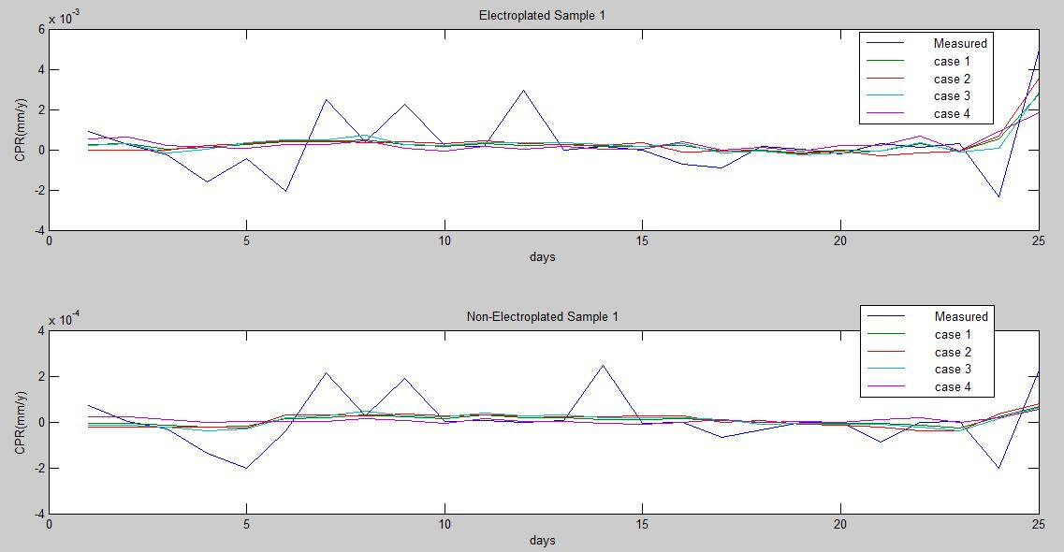

Figure 12: ANN graphical result for soil sample 1 (electroplated and non-electroplated)

The graphs below show the MANN results for the non-electroplated and the electroplated specimens in sample 2. The plots for the four cases too are distant from the measured (reference) plot (blue line). This is also due to a variation in training the tool.

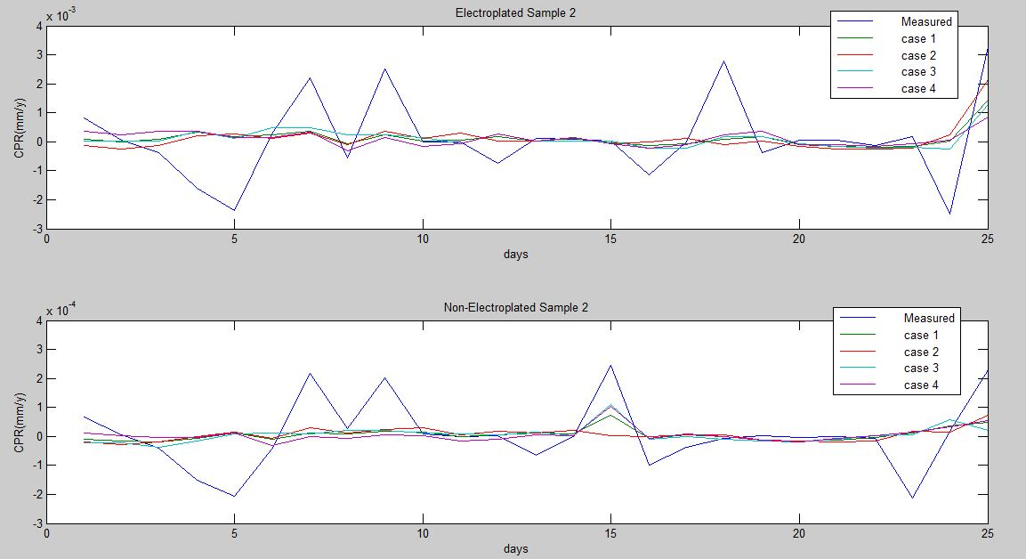

Figure 13: ANN graphical result for soil sample 2 (electroplated and non-electroplated)

Here, the graphs show the MANN results for the non-electroplated and the electroplated specimens in sample 3 to match well except for variations in days 13 and 15 in the case of the electroplated specimen and only day 17 in the case of the non-electroplated specimen. This is due to a variation in training the tool.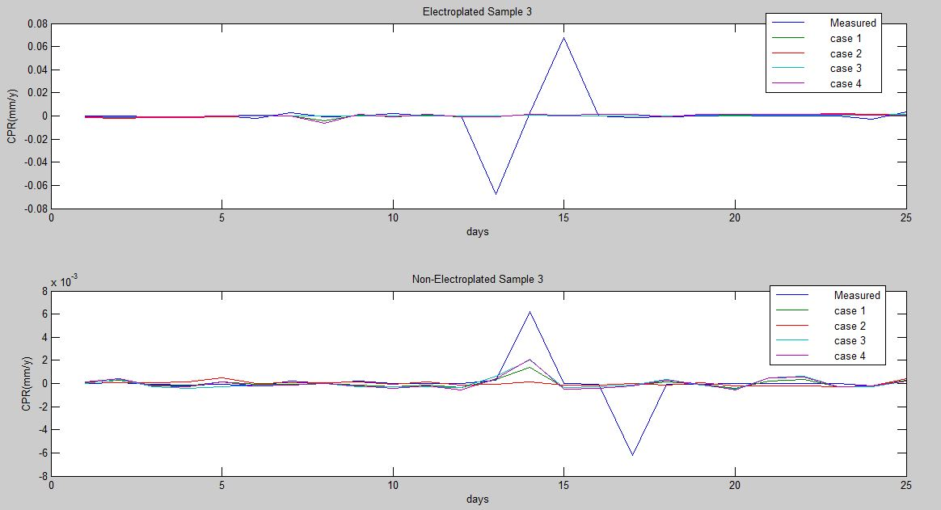

Figure 14: ANN graphical result for soil sample 4 (electroplated and non-electroplated)

Unlike the earlier plotted graphs, the electroplated graph for the sample 3 matches so well that there were only two outlying data at days 1 and 2 whereas for the non-electroplated specimen, did not really conform but conforms between days 9 and 13, days19 and 23 and day 25.

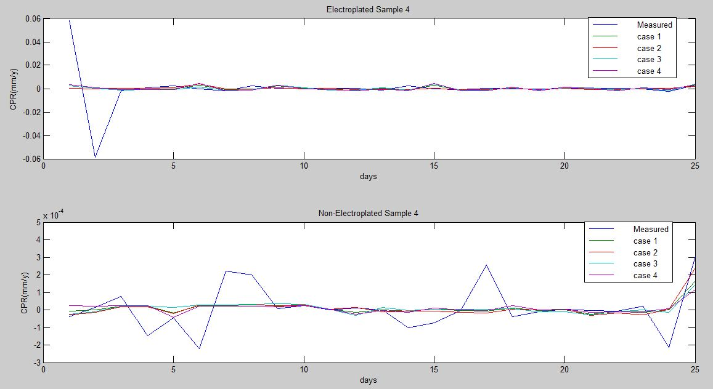

Figure 15: ANN graphical result for soil sample 4 (electroplated and non-electroplated)

The results for specimens in sample 5 have two variations in their measured plot. For the electroplated specimen, the variations are at days 7 and 12 while for the non-electroplated specimen, the variations are on days 8 and 14.

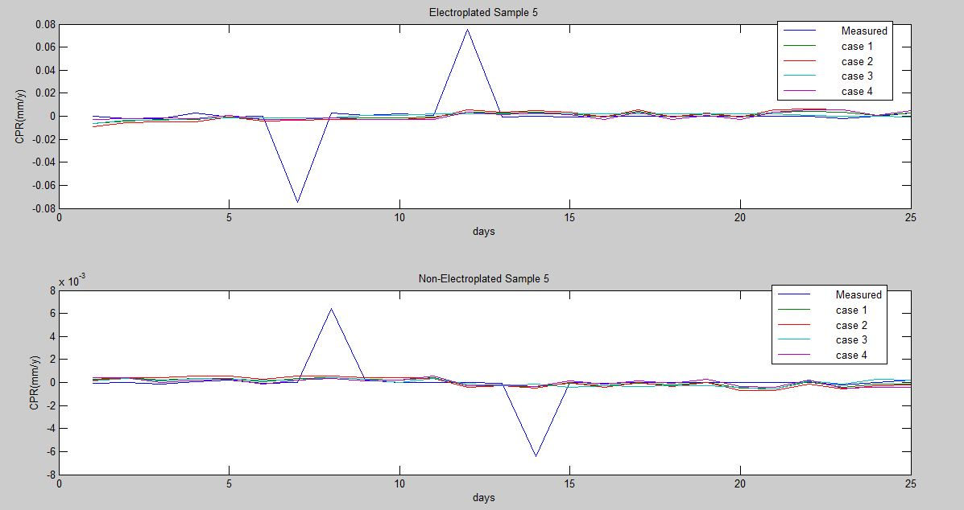

Figure 16: ANN graphical result for soil sample 5 (electroplated and non-electroplated)

Determination of the relevance of each case was done by using the percentage error method on the modified artificial neutral network:

The results from the modified artificial neural network also include the percentage error of each case. This is presented below:

Percentage errors

case 1: -4.0410e-013

case 2: -6.0080e-013

case 3: -4.3490e-013

case 4: -1.7660e-013

From the above results, it is therefore deduced that;

* Case 2: Soil sample temperature and the immediate surrounding temperature (has the strongest effect on the corrosion penetration rate).
* Case 3: Soil sample temperature and the pH
* Case 1: The soil sample temperature, immediate surrounding temperature and the pH value)
* Case 4: Immediate temperature and the pH value (has the weakest effect on the corrosion penetration rate).

The cases above are arranged in the order of relevance on the corrosion penetration rate.

ANN graphical result for soil sample 5 (electroplated and non-electroplated)

## Microstructural metallographic examination

To properly examine the corrosion penetration rate visually, an aid was required. A micrograph machine was used at Obafemi Awolowo University, Ile-Ife. This enabled the physical structure of the materials to be viewed at a micro-level up to 20µm scale. The results of the micrograph microstructure with explanations are presented below in figures 11 to 20:

Below (figure 11) is the metallographic of the non-electroplated specimen in soil sample 1. The dark regions are showing the areas grossly affected by corrosion.

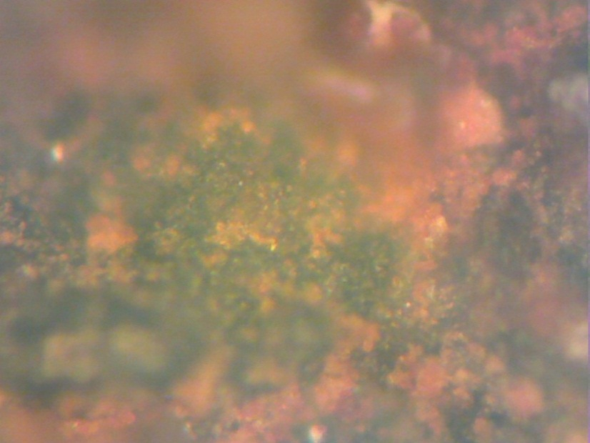

Figure 17: Micrograph microstructure of the non-plated steel specimen in soil sample 1

Figure 12 as show below has some dark irregular straight strips and spots. These are the regions affected by corrosion. The light regions are the protected parts that are not in corroded.

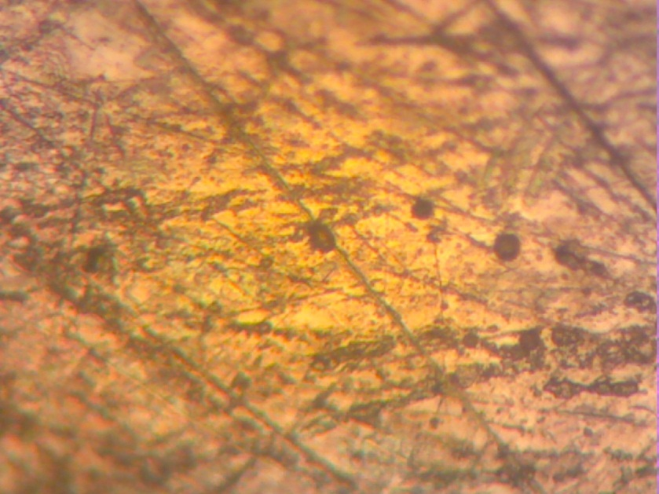

Figure 18: Micrograph microstructure of the nickel-plated steel specimen in soil sample 1

Figure 13 shows the metallographic result for the non-electroplated specimen in soil sample 2. Compared to figure 14 (the electroplated specimen in the same soil sample) is more corroded by presence of more dark regions.

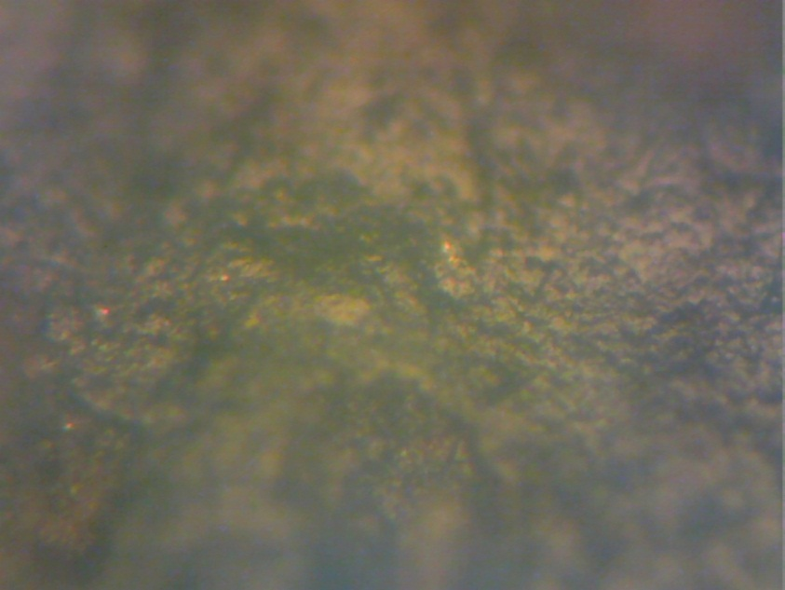

Figure 19: Micrograph microstructure of the non-plated steel specimen in soil sample 2

The metallographic result for the electroplated specimen in sample 2 (figure14) shows a very clear light face. This is interpreted that corrosion was very minimal if present on the specimen.

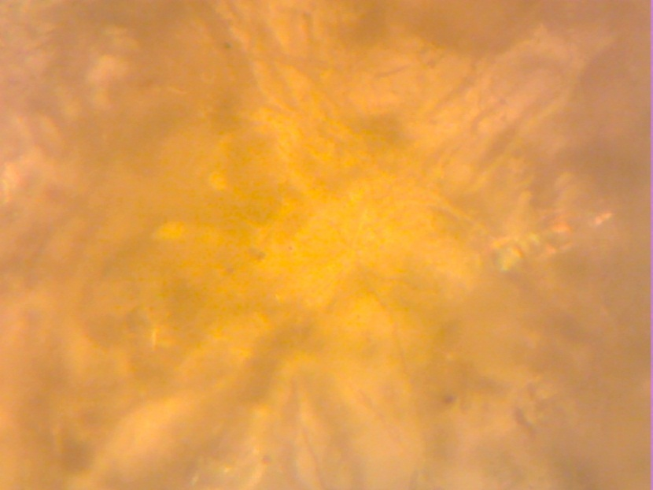

Figure 20: Micrograph microstructure of the nickel-plated steel specimen in soil sample 2

Result on figure 15 is similar to the results of the other non-electroplated specimens shown above. The dark regions are the regions that were affected by corrosion.

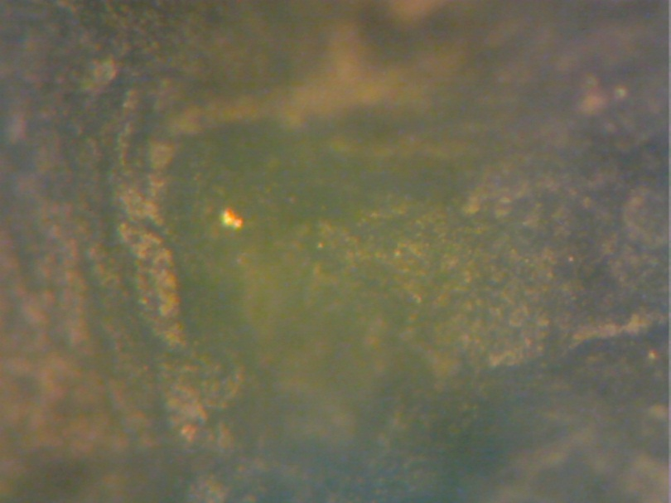

Figure 21: Micrograph microstructure of the non-plated steel specimen in soil sample 3

Result on figure 16 is similar to the results of the other electroplated specimens shown above. The light regions are the regions that were less affected by corrosion.

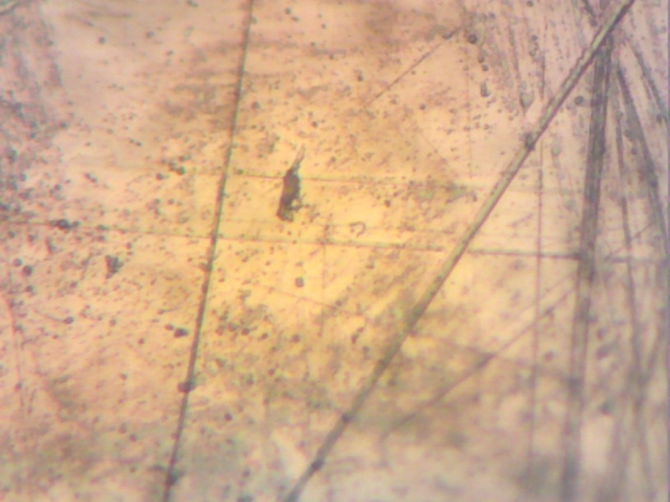

Figure 22: Micrograph microstructure of the nickel-plated steel specimen in soil sample 3

Result on figure 17 is similar to the results of the other non-electroplated specimens shown above. The dark regions are the regions that were affected by corrosion.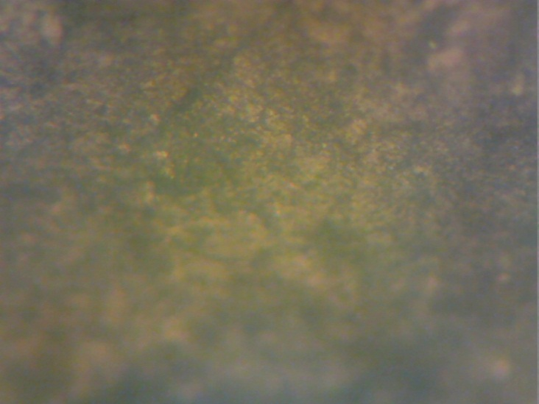

Figure 23: Micrograph microstructure of the non-plated steel specimen in soil sample 4

Result on figure 18 is similar to the results of the other electroplated specimens shown above. The light regions are the regions that were less affected by corrosion.

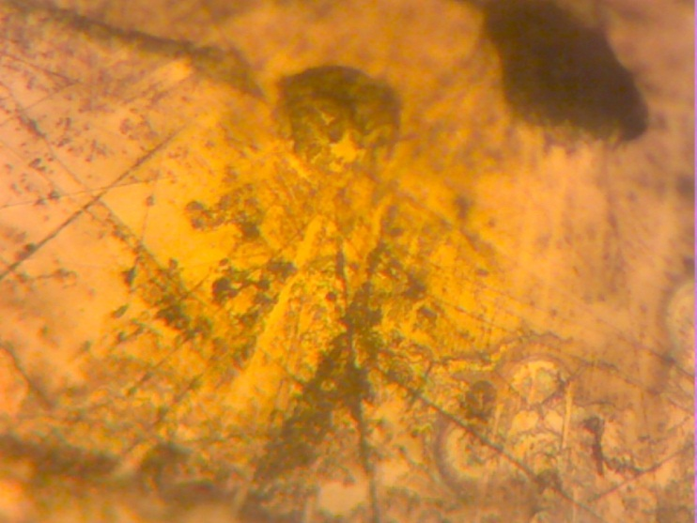

Figure 24: Micrograph microstructure of the nickel-plated steel specimen in soil sample 4

Result on figure 19 is similar to the results of the other non-electroplated specimens shown above. The dark regions are the regions that were affected by corrosion.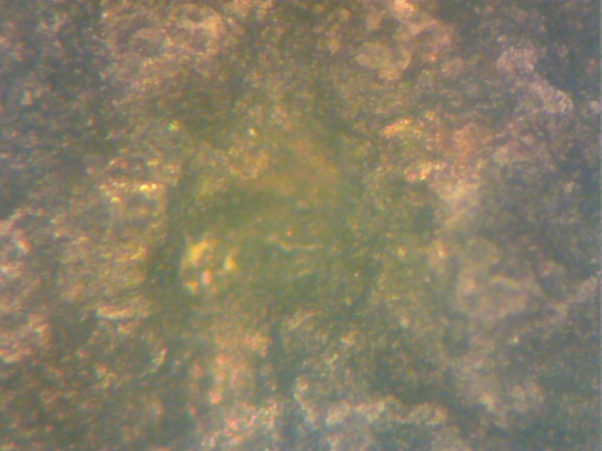

Figure 25: Micrograph microstructure of the nickel-plated steel specimen in soil sample 5

Result on figure 20 is similar to the results of the other electroplated specimens shown above. The light regions are the regions that were less affected by corrosion.

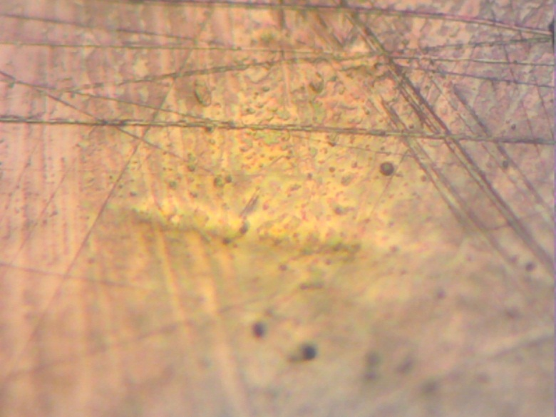

Figure 26: Micrograph microstructure of the nickel-plated steel specimen in soil sample 5

In summary, visual results from the micrograph microstructure show some dark region on the specimens. These dark regions are interpreted as areas that are more affected by the corrosion penetration and of course, the non-electroplated specimens have more dark regions relative to the electroplated specimen. These micrograph microstructure results therefore also confirm that the corrosion penetration was more prominent on the non-electroplated specimens.

# CHAPTER 5

# CONCLUSIONS AND RECOMMENDATIONS

## 5.1 Conclusion

* External underground corrosion behaviour of buried nickel plated AISI 1015 steel pipes in oil and gas environment were optimally investigated and characterized using weight loss method and modelled using artificial neural networks.
* The results obtained showed that the nickel-electroplated AISI 1015 steel generally offers a better corrosion resistance relative to the non-electroplated one.
* Modified Artificial Neural Network relationships between the varied selected input parameters that affects corrosion rate (soil sample temperature, immediate environment temperature and pH value) and the output parameter (Corrosion Penetration Rate) were derived.
* This work of study as accomplished successfully, has remarkably append to the reservoir of information that abounds in the world of oil and gas when it comes to corrosion study

## 5.2 Recommendation

In the course of this experiment, some other factors that affect the corrosion penetration rate of the selected material like pressure, relative humidity, presence of some micro-bacteria and chemical compounds were not considered. For further study, it is recommended that these factors be considered.

# APPENDIX

Appendix 1: All required data for the non-nickel plated steel specimen in soil sample 1

|  |  |  |  |  |  |  |  |
| --- | --- | --- | --- | --- | --- | --- | --- |
|  | Input Data |  |  |  | Output Data |  |  |
|  | Soil Sample T ( ͦC) | Atm T ( ͦC) | pH |  | Mass(g) | Mass Diff. (g) | CPR (mm/y) |
| Day 1 | 26.2 | 29.2 | 6.9 |  | 63.2302 | 0.0000 | 0 |
| Day 2 | 27.8 | 29.5 | 7.2 |  | 63.2244 | 0.0058 | 0.000116449 |
| Day 3 | 26.0 | 29.2 | 7.5 |  | 63.2045 | 0.0199 | 0.000399539 |
| Day 4 | 26.8 | 28.2 | 7.5 |  | 63.2405 | -0.0360 | -0.00072278 |
| Day 5 | 25.0 | 26.0 | 7.5 |  | 63.1936 | 0.0469 | 0.000941627 |
| Day 6 | 25.0 | 25.8 | 7.4 |  | 63.1804 | 0.0132 | 0.000265021 |
| Day 7 | 25.0 | 26.0 | 7.8 |  | 63.1943 | -0.0139 | -0.00027908 |
| Day 8 | 26.0 | 25.2 | 7.9 |  | 63.0773 | 0.1170 | 0.002349049 |
| Day 9 | 25.2 | 26.0 | 8.1 |  | 63.1594 | -0.0821 | -0.00164835 |
| Day 10 | 25.6 | 24.8 | 7.8 |  | 63.1813 | -0.0219 | -0.00043969 |
| Day 11 | 26.0 | 28.0 | 8.0 |  | 63.1696 | 0.0117 | 0.000234905 |
| Day 12 | 26.0 | 26.6 | 7.8 |  | 63.1608 | 0.0088 | 0.000176681 |
| Day 13 | 26.2 | 28.6 | 7.8 |  | 63.1523 | 0.0085 | 0.000170657 |
| Day 14 | 26.8 | 28.0 | 7.9 |  | 63.2001 | -0.0478 | -0.0009597 |
| Day 15 | 27.0 | 29.0 | 8.1 |  | 63.1983 | 0.0018 | 3.61392E-05 |
| Day 16 | 28.0 | 28.8 | 8.1 |  | 63.1837 | 0.0146 | 0.000293129 |
| Day 17 | 26.0 | 28.4 | 7.8 |  | 63.0314 | 0.1523 | 0.003057779 |
| Day 18 | 25.6 | 26.8 | 7.7 |  | 63.1391 | -0.1077 | -0.00216233 |
| Day 19 | 25.8 | 26.8 | 7.7 |  | 63.0112 | 0.1279 | 0.002567892 |
| Day 20 | 27.0 | 26.0 | 7.8 |  | 63.0212 | -0.0100 | -0.00020077 |
| Day 21 | 28.0 | 31.0 | 7.7 |  | 63.1427 | -0.1215 | -0.0024394 |
| Day 22 | 26.8 | 27.5 | 8.2 |  | 63.1348 | 0.0079 | 0.000158611 |
| Day 23 | 26.2 | 27.0 | 8.1 |  | 63.1355 | -0.0007 | -1.4054E-05 |
| Day 24 | 27.4 | 28.8 | 8.3 |  | 63.1192 | 0.0163 | 0.000327261 |
| Day 25 | 29.0 | 31.6 | 7.3 |  | 62.8637 | 0.2555 | 0.00512976 |

Appendix 2: All required data for the nickel plated steel specimen in soil sample 1

|  |  |  |  |  |  |  |  |
| --- | --- | --- | --- | --- | --- | --- | --- |
|  | Input Data |  |  |  | Output Data |  |  |
|  | Soil Sample Temperature ͦC | Atmospheric Temperature ͦC | pH |  | Mass(g) | Mass Diff. (g) | CPR (mm/y) |
| Day 1 | 26.2 | 29.2 | 7.1 |  | 59.5520 | 0.0000 | 0 |
| Day 2 | 28.0 | 29.5 | 7.3 |  | 59.5530 | -0.0010 | -1.77299E-05 |
| Day 3 | 26.0 | 29.2 | 7.6 |  | 59.5391 | 0.0139 | 0.000246445 |
| Day 4 | 26.8 | 28.2 | 7.7 |  | 59.5766 | -0.0375 | -0.00066487 |
| Day 5 | 25.0 | 26.0 | 7.6 |  | 59.5374 | 0.0392 | 0.000695011 |
| Day 6 | 25.0 | 25.8 | 7.6 |  | 59.5356 | 0.0018 | 3.19138E-05 |
| Day 7 | 25.0 | 26.0 | 7.8 |  | 59.5529 | -0.0173 | -0.000306727 |
| Day 8 | 26.0 | 25.2 | 7.9 |  | 59.4450 | 0.1079 | 0.001913054 |
| Day 9 | 25.0 | 26.0 | 8.1 |  | 59.5230 | -0.0780 | -0.00138293 |
| Day 10 | 25.6 | 24.8 | 8.0 |  | 59.5454 | -0.0224 | -0.000397149 |
| Day 11 | 26.0 | 28.0 | 8.0 |  | 59.5432 | 0.0022 | 3.90057E-05 |
| Day 12 | 26.0 | 26.6 | 7.7 |  | 59.5408 | 0.0024 | 4.25517E-05 |
| Day 13 | 26.2 | 28.6 | 7.8 |  | 59.5370 | 0.0038 | 6.73735E-05 |
| Day 14 | 27.2 | 28.0 | 7.7 |  | 59.5869 | -0.0499 | -0.000884721 |
| Day 15 | 27.0 | 29.0 | 7.8 |  | 59.5871 | -0.0002 | -3.54598E-06 |
| Day 16 | 28.2 | 28.6 | 7.9 |  | 59.5858 | 0.0013 | 2.30488E-05 |
| Day 17 | 26.2 | 28.4 | 8.0 |  | 59.4462 | 0.1396 | 0.002475091 |
| Day 18 | 25.0 | 26.8 | 7.9 |  | 59.5608 | -0.1146 | -0.002031844 |
| Day 19 | 25.8 | 26.8 | 7.9 |  | 59.4389 | 0.1219 | 0.002161272 |
| Day 20 | 26.8 | 26.0 | 8.1 |  | 59.4584 | -0.0195 | -0.000345733 |
| Day 21 | 28.8 | 31.0 | 7.9 |  | 59.5734 | -0.1150 | -0.002038936 |
| Day 22 | 26.2 | 27.4 | 8.2 |  | 59.5767 | -0.0033 | -5.85086E-05 |
| Day 23 | 26.2 | 27.0 | 8.0 |  | 59.5773 | -0.0006 | -1.06379E-05 |
| Day 24 | 27.0 | 28.8 | 8.4 |  | 59.5793 | -0.0020 | -3.54598E-05 |
| Day 25 | 29.0 | 31.6 | 7.5 |  | 59.4509 | 0.1284 | 0.002276516 |

Appendix 3: All required data for the non-plated steel specimen in soil sample 2

|  |  |  |  |  |  |  |  |
| --- | --- | --- | --- | --- | --- | --- | --- |
|  | Input Data |  |  |  | Output Data |  |  |
|  | Soil Sample T ( ͦC) | Atm T ( ͦC) | pH |  | Mass(g) | Mass Diff. (g) | CPR (mm/y) |
| Day 1 | 26.2 | 29.4 | 7.4 |  | 63.1684 | 0.0000 | 0 |
| Day 2 | 28.0 | 29.0 | 7.4 |  | 63.1753 | -0.0069 | -0.00013853 |
| Day 3 | 26.0 | 29.2 | 7.7 |  | 63.1610 | 0.0143 | 0.000287106 |
| Day 4 | 26.8 | 28.0 | 7.7 |  | 63.1995 | -0.0385 | -0.00077298 |
| Day 5 | 25.2 | 26.0 | 7.7 |  | 63.1564 | 0.0431 | 0.000865333 |
| Day 6 | 25.2 | 25.5 | 7.7 |  | 63.1532 | 0.0032 | 6.42475E-05 |
| Day 7 | 25.2 | 26.0 | 7.7 |  | 63.1719 | -0.0187 | -0.00037545 |
| Day 8 | 26.0 | 25.8 | 7.7 |  | 63.0580 | 0.1139 | 0.002286809 |
| Day 9 | 25.6 | 26.0 | 7.7 |  | 63.1409 | -0.0829 | -0.00166441 |
| Day 10 | 26.0 | 24.8 | 7.8 |  | 63.1691 | -0.0282 | -0.00056618 |
| Day 11 | 26.8 | 28.0 | 7.8 |  | 63.1626 | 0.0065 | 0.000130503 |
| Day 12 | 26.8 | 26.6 | 7.8 |  | 63.1587 | 0.0039 | 7.83016E-05 |
| Day 13 | 26.8 | 28.8 | 7.8 |  | 63.1567 | 0.0020 | 4.01547E-05 |
| Day 14 | 26.8 | 28.2 | 7.9 |  | 63.2149 | -0.0582 | -0.0011685 |
| Day 15 | 27.2 | 29.0 | 7.8 |  | 63.2117 | 0.0032 | 6.42475E-05 |
| Day 16 | 28.0 | 28.6 | 8.1 |  | 63.2025 | 0.0092 | 0.000184712 |
| Day 17 | 27.0 | 28.4 | 7.7 |  | 63.0595 | 0.1430 | 0.002871059 |
| Day 18 | 25.6 | 27.0 | 7.8 |  | 63.1818 | -0.1223 | -0.00245546 |
| Day 19 | 26.0 | 26.8 | 7.8 |  | 63.0530 | 0.1288 | 0.002585961 |
| Day 20 | 27.0 | 26.0 | 7.7 |  | 63.0723 | -0.0193 | -0.00038749 |
| Day 21 | 28.2 | 31.0 | 7.9 |  | 63.2001 | -0.1278 | -0.00256588 |
| Day 22 | 26.8 | 27.4 | 7.9 |  | 63.1997 | 0.0004 | 8.03094E-06 |
| Day 23 | 26.4 | 27.0 | 7.9 |  | 63.2001 | -0.0004 | -8.0309E-06 |
| Day 24 | 27.0 | 29.0 | 7.8 |  | 63.1979 | 0.0022 | 4.41701E-05 |
| Day 25 | 29.0 | 31.8 | 7.8 |  | 63.0291 | 0.1688 | 0.003389055 |

Appendix 4: All required data for the nickel-plated steel specimen in soil sample 2

|  |  |  |  |  |  |  |  |
| --- | --- | --- | --- | --- | --- | --- | --- |
|  | Input Data |  |  |  | Output Data |  |  |
|  | Soil Sample T ( ͦC) | Atm T ( ͦC) | pH |  | Mass(g) | Mass Diff. (g) | CPR (mm/y) |
| Day 1 | 26.2 | 29.4 | 7.4 |  | 62.2801 | 0.0000 | 0 |
| Day 2 | 28.0 | 29.0 | 7.5 |  | 62.2841 | -0.0040 | -7.09195E-05 |
| Day 3 | 26.0 | 29.2 | 7.7 |  | 62.2691 | 0.0150 | 0.000265948 |
| Day 4 | 26.4 | 28.0 | 7.7 |  | 62.3059 | -0.0368 | -0.000652459 |
| Day 5 | 25.0 | 26.0 | 7.7 |  | 62.2690 | 0.0369 | 0.000654232 |
| Day 6 | 25.0 | 25.5 | 7.7 |  | 62.2652 | 0.0038 | 6.73735E-05 |
| Day 7 | 25.0 | 26.0 | 7.9 |  | 62.2877 | -0.0225 | -0.000398922 |
| Day 8 | 26.0 | 25.8 | 8.0 |  | 62.1733 | 0.1144 | 0.002028298 |
| Day 9 | 25.2 | 26.0 | 7.9 |  | 62.2586 | -0.0853 | -0.001512358 |
| Day 10 | 25.8 | 24.8 | 7.8 |  | 62.2832 | -0.0246 | -0.000436155 |
| Day 11 | 26.2 | 28.0 | 7.9 |  | 62.2815 | 0.0017 | 3.01408E-05 |
| Day 12 | 26.0 | 26.6 | 7.8 |  | 62.2766 | 0.0049 | 8.68764E-05 |
| Day 13 | 27.0 | 28.8 | 7.8 |  | 62.2747 | 0.0019 | 3.36868E-05 |
| Day 14 | 26.8 | 28.2 | 7.8 |  | 62.3313 | -0.0566 | -0.001003511 |
| Day 15 | 27.2 | 29.0 | 8.0 |  | 62.3312 | 0.0001 | 1.77299E-06 |
| Day 16 | 28.4 | 28.6 | 8.1 |  | 62.3218 | 0.0094 | 0.000166661 |
| Day 17 | 26.6 | 28.4 | 8.2 |  | 62.1837 | 0.1381 | 0.002448496 |
| Day 18 | 25.4 | 27.0 | 8.0 |  | 62.3000 | -0.1163 | -0.002061985 |
| Day 19 | 25.8 | 26.8 | 7.9 |  | 62.1773 | 0.1227 | 0.002175456 |
| Day 20 | 26.8 | 26.0 | 8.0 |  | 62.1988 | -0.0215 | -0.000381192 |
| Day 21 | 28.2 | 31.0 | 8.0 |  | 62.3193 | -0.1205 | -0.00213645 |
| Day 22 | 26.8 | 27.4 | 7.8 |  | 62.3237 | -0.0044 | -7.80115E-05 |
| Day 23 | 26.4 | 27.0 | 7.8 |  | 62.3248 | -0.0011 | -1.95029E-05 |
| Day 24 | 27.0 | 29.0 | 7.9 |  | 62.3271 | -0.0023 | -4.07787E-05 |
| Day 25 | 28.4 | 31.8 | 8.0 |  | 62.1973 | 0.1298 | 0.002301338 |

Appendix 5: All required data for the non-plated steel specimen in soil sample 3

|  |  |  |  |  |  |  |  |
| --- | --- | --- | --- | --- | --- | --- | --- |
|  | Input Data |  |  |  | Output Data |  |  |
|  | Soil Sample T ( ͦC) | Atm T ( ͦC) | pH |  | Mass(g) | Mass Diff. (g) | CPR (mm/y) |
| Day 1 | 26.0 | 29.0 | 7.2 |  | 66.5351 | 0.0000 | 0 |
| Day 2 | 27.8 | 29.2 | 7.2 |  | 66.5281 | 0.0070 | 0.000140541 |
| Day 3 | 25.2 | 26.5 | 7.9 |  | 66.5176 | 0.0105 | 0.000210812 |
| Day 4 | 27.0 | 27.6 | 7.5 |  | 66.5281 | -0.0105 | -0.00021081 |
| Day 5 | 25.0 | 26.2 | 7.5 |  | 66.5145 | 0.0136 | 0.000273052 |
| Day 6 | 25.0 | 25.9 | 7.5 |  | 66.4997 | 0.0148 | 0.000297145 |
| Day 7 | 25.0 | 26.2 | 7.6 |  | 66.5236 | -0.0239 | -0.00047985 |
| Day 8 | 26.0 | 26.0 | 7.8 |  | 66.4031 | 0.1205 | 0.002419319 |
| Day 9 | 25.0 | 26.0 | 7.9 |  | 66.4868 | -0.0837 | -0.00168047 |
| Day 10 | 25.6 | 24.6 | 7.6 |  | 66.5141 | -0.0273 | -0.00054811 |
| Day 11 | 26.0 | 28.0 | 7.8 |  | 66.5096 | 0.0045 | 9.0348E-05 |
| Day 12 | 26.0 | 26.0 | 7.7 |  | 66.5016 | 0.0080 | 0.000160619 |
| Day 13 | 26.6 | 28.4 | 7.7 |  | 66.4989 | 0.0027 | 5.42088E-05 |
| Day 14 | 26.6 | 28.0 | 7.8 |  | 66.5572 | -0.0583 | -0.00117051 |
| Day 15 | 27.0 | 28.0 | 7.9 |  | 66.5576 | -0.0004 | -8.0309E-06 |
| Day 16 | 27.8 | 28.2 | 8.0 |  | 66.5473 | 0.0103 | 0.000206797 |
| Day 17 | 26.2 | 28.0 | 8.0 |  | 66.3950 | 0.1523 | 0.003057779 |
| Day 18 | 25.2 | 26.8 | 7.9 |  | 66.5185 | -0.1235 | -0.00247955 |
| Day 19 | 25.2 | 26.6 | 7.9 |  | 66.3866 | 0.1319 | 0.002648201 |
| Day 20 | 26.8 | 26.0 | 7.7 |  | 66.4057 | -0.0191 | -0.00038348 |
| Day 21 | 28.0 | 30.0 | 7.9 |  | 66.5353 | -0.1296 | -0.00260202 |
| Day 22 | 26.2 | 27.0 | 7.9 |  | 63.0510 | 3.4843 | 0.069955472 |
| Day 23 | 26.0 | 26.0 | 7.9 |  | 66.5388 | -3.4878 | -0.07002574 |
| Day 24 | 26.8 | 27.8 | 8.1 |  | 66.5411 | -0.0023 | -4.6178E-05 |
| Day 25 | 29.0 | 31.4 | 7.9 |  | 66.3622 | 0.1789 | 0.003591836 |

Appendix 6: All required data for the nickel-plated steel specimen in soil sample 3

|  |  |  |  |  |  |  |  |
| --- | --- | --- | --- | --- | --- | --- | --- |
|  | Input Data |  |  |  | Output Data |  |  |
|  | Soil Sample T ( ͦC) | Atm T ( ͦC) | pH |  | Mass(g) | Mass Diff. (g) | CPR (mm/y) |
| Day 1 | 26.2 | 29.0 | 7.1 |  | 63.0056 | 0.0000 | 0 |
| Day 2 | 27.2 | 29.2 | 7.3 |  | 63.0125 | -0.0069 | -0.000122336 |
| Day 3 | 26.0 | 26.5 | 7.6 |  | 63.0000 | 0.0125 | 0.000221623 |
| Day 4 | 26.4 | 27.6 | 7.5 |  | 63.0408 | -0.0408 | -0.000723379 |
| Day 5 | 24.9 | 26.2 | 7.5 |  | 62.9985 | 0.0423 | 0.000749974 |
| Day 6 | 24.8 | 25.9 | 7.6 |  | 62.9924 | 0.0061 | 0.000108152 |
| Day 7 | 25.0 | 26.2 | 7.7 |  | 63.0153 | -0.0229 | -0.000406014 |
| Day 8 | 26.0 | 26.0 | 7.7 |  | 62.8997 | 0.1156 | 0.002049574 |
| Day 9 | 25.0 | 26.0 | 7.8 |  | 62.9884 | -0.0887 | -0.00157264 |
| Day 10 | 25.2 | 24.6 | 7.7 |  | 63.0108 | -0.0224 | -0.000397149 |
| Day 11 | 26.0 | 28.0 | 7.7 |  | 63.0073 | 0.0035 | 6.20546E-05 |
| Day 12 | 26.0 | 26.0 | 7.7 |  | 63.0020 | 0.0053 | 9.39683E-05 |
| Day 13 | 26.0 | 28.4 | 7.8 |  | 63.0032 | -0.0012 | -2.12759E-05 |
| Day 14 | 26.2 | 28.0 | 7.7 |  | 63.0589 | -0.0557 | -0.000987554 |
| Day 15 | 27.0 | 28.0 | 7.8 |  | 63.0595 | -0.0006 | -1.06379E-05 |
| Day 16 | 27.4 | 28.2 | 7.9 |  | 63.0482 | 0.0113 | 0.000200348 |
| Day 17 | 26.0 | 28.0 | 8.0 |  | 62.8924 | 0.1558 | 0.002762315 |
| Day 18 | 25.2 | 26.8 | 7.9 |  | 63.0283 | -0.1359 | -0.00240949 |
| Day 19 | 25.2 | 26.6 | 7.9 |  | 62.9043 | 0.1240 | 0.002198505 |
| Day 20 | 26.4 | 26.0 | 7.9 |  | 62.9261 | -0.0218 | -0.000386511 |
| Day 21 | 27.6 | 30.0 | 7.9 |  | 63.0484 | -0.1223 | -0.002168364 |
| Day 22 | 26.2 | 27.0 | 7.9 |  | 66.5440 | -3.4956 | -0.061976556 |
| Day 23 | 26.0 | 26.0 | 8.1 |  | 63.0530 | 3.4910 | 0.061894998 |
| Day 24 | 27.0 | 27.8 | 8.0 |  | 63.0539 | -0.0009 | -1.59569E-05 |
| Day 25 | 28.8 | 31.4 | 7.6 |  | 62.8885 | 0.1654 | 0.002932522 |

Appendix 7: All required data for the non-plated steel specimen in soil sample 4

|  |  |  |  |  |  |  |  |
| --- | --- | --- | --- | --- | --- | --- | --- |
|  | Input Data |  |  |  | Output Data |  |  |
|  | Soil Sample T ( ͦC) | Atm T ( ͦC) | pH |  | Mass(g) | Mass Diff. (g) | CPR (mm/y) |
| Day 1 | 26.0 | 29.8 | 7.7 |  | 63.0938 | 0.0000 | 0 |
| Day 2 | 27.0 | 29.5 | 7.5 |  | 63.1020 | -0.0082 | -0.00016463 |
| Day 3 | 25.2 | 26.0 | 7.8 |  | 63.0780 | 0.0240 | 0.000481856 |
| Day 4 | 26.0 | 27.4 | 8.0 |  | 63.1125 | -0.0345 | -0.00069267 |
| Day 5 | 24.9 | 26.2 | 8.0 |  | 63.0702 | 0.0423 | 0.000849271 |
| Day 6 | 24.5 | 25.8 | 7.8 |  | 60.0633 | 3.0069 | 0.060370551 |
| Day 7 | 24.5 | 26.2 | 7.9 |  | 63.0796 | -3.0163 | -0.06055928 |
| Day 8 | 25.0 | 26.0 | 8.0 |  | 62.9587 | 0.1209 | 0.00242735 |
| Day 9 | 24.8 | 26.2 | 8.0 |  | 63.0480 | -0.0893 | -0.00179291 |
| Day 10 | 25.0 | 24.8 | 8.2 |  | 63.0666 | -0.0186 | -0.00037344 |
| Day 11 | 25.2 | 27.2 | 7.9 |  | 63.0590 | 0.0076 | 0.000152588 |
| Day 12 | 25.8 | 26.0 | 8.1 |  | 63.0474 | 0.0116 | 0.000232897 |
| Day 13 | 25.8 | 28.0 | 8.0 |  | 63.0332 | 0.0142 | 0.000285098 |
| Day 14 | 25.8 | 27.8 | 7.9 |  | 63.0907 | -0.0575 | -0.00115445 |
| Day 15 | 26.0 | 27.8 | 8.0 |  | 63.0870 | 0.0037 | 7.42862E-05 |
| Day 16 | 26.6 | 28.2 | 8.0 |  | 63.0723 | 0.0147 | 0.000295137 |
| Day 17 | 25.8 | 28.0 | 8.1 |  | 62.9438 | 0.1285 | 0.002579938 |
| Day 18 | 25.0 | 26.6 | 8.1 |  | 63.0482 | -0.1044 | -0.00209607 |
| Day 19 | 25.0 | 26.6 | 8.0 |  | 62.9218 | 0.1264 | 0.002537776 |
| Day 20 | 26.0 | 26.0 | 8.2 |  | 62.9390 | -0.0172 | -0.00034533 |
| Day 21 | 27.0 | 30.0 | 8.1 |  | 63.0611 | -0.1221 | -0.00245144 |
| Day 22 | 26.0 | 27.0 | 8.1 |  | 63.0640 | -0.0029 | -5.8224E-05 |
| Day 23 | 26.0 | 26.0 | 8.2 |  | 63.0571 | 0.0069 | 0.000138534 |
| Day 24 | 26.2 | 27.8 | 8.2 |  | 63.0558 | 0.0013 | 2.61005E-05 |
| Day 25 | 28.0 | 31.0 | 7.8 |  | 62.9179 | 0.1379 | 0.002768665 |

Appendix 8: All required data for the nickel-plated steel specimen in soil sample 4

|  |  |  |  |  |  |  |  |
| --- | --- | --- | --- | --- | --- | --- | --- |
|  | Input Data |  |  |  | Output Data |  |  |
|  | Soil Sample T ( ͦC) | Atm T ( ͦC) | pH |  | Mass(g) | Mass Diff. (g) | CPR (mm/y) |
| Day 1 | 25.8 | 29.8 | 7.5 |  | 62.7529 | 0.0000 | 0 |
| Day 2 | 27.0 | 29.5 | 7.5 |  | 62.7577 | -0.0048 | -8.51034E-05 |
| Day 3 | 25.4 | 26.0 | 7.8 |  | 62.7429 | 0.0148 | 0.000262402 |
| Day 4 | 26.0 | 27.4 | 7.7 |  | 62.7848 | -0.0419 | -0.000742882 |
| Day 5 | 24.8 | 26.2 | 7.8 |  | 62.7415 | 0.0433 | 0.000767704 |
| Day 6 | 24.5 | 25.8 | 7.8 |  | 62.7326 | 0.0089 | 0.000157796 |
| Day 7 | 24.4 | 26.2 | 7.8 |  | 62.7549 | -0.0223 | -0.000395376 |
| Day 8 | 25.2 | 26.0 | 7.7 |  | 62.6419 | 0.1130 | 0.002003476 |
| Day 9 | 24.8 | 26.2 | 7.8 |  | 62.7246 | -0.0827 | -0.001466261 |
| Day 10 | 25.0 | 24.8 | 8.0 |  | 62.7499 | -0.0253 | -0.000448566 |
| Day 11 | 25.2 | 27.2 | 7.8 |  | 62.7469 | 0.0030 | 5.31896E-05 |
| Day 12 | 25.8 | 26.0 | 8.1 |  | 62.7405 | 0.0064 | 0.000113471 |
| Day 13 | 25.8 | 28.0 | 7.9 |  | 62.7397 | 0.0008 | 1.41839E-05 |
| Day 14 | 25.8 | 27.8 | 8.0 |  | 62.7966 | -0.0569 | -0.00100883 |
| Day 15 | 26.0 | 27.8 | 7.9 |  | 62.7977 | -0.0011 | -1.95029E-05 |
| Day 16 | 27.0 | 28.8 | 7.3 |  | 62.7857 | 0.0120 | 0.000212759 |
| Day 17 | 26.0 | 28.0 | 7.9 |  | 62.6416 | 0.1441 | 0.002554875 |
| Day 18 | 25.0 | 26.6 | 7.9 |  | 62.7655 | -0.1239 | -0.002196732 |
| Day 19 | 25.0 | 26.6 | 7.9 |  | 62.6416 | 0.1239 | 0.002196732 |
| Day 20 | 26.0 | 26.0 | 7.8 |  | 62.6625 | -0.0209 | -0.000370554 |
| Day 21 | 27.0 | 30.0 | 8.0 |  | 62.7838 | -0.1213 | -0.002150634 |
| Day 22 | 26.0 | 27.0 | 8.0 |  | 62.7898 | -0.0060 | -0.000106379 |
| Day 23 | 26.0 | 26.0 | 8.0 |  | 62.7877 | 0.0021 | 3.72327E-05 |
| Day 24 | 26.6 | 27.8 | 8.0 |  | 62.7891 | -0.0014 | -2.48218E-05 |
| Day 25 | 27.8 | 31.0 | 7.9 |  | 62.6173 | 0.1718 | 0.003045993 |

Appendix 9: All required data for the non-plated steel specimen in soil sample 5

|  |  |  |  |  |  |  |  |
| --- | --- | --- | --- | --- | --- | --- | --- |
|  | Input Data |  |  |  | Output Data |  |  |
|  | Soil Sample T ( ͦC) | Atm T ( ͦC) | pH |  | Mass(g) | Mass Diff. (g) | CPR (mm/y) |
| Day 1 | 26.0 | 29.8 | 7.0 |  | 64.6009 | 0.0000 | 0 |
| Day 2 | 27.0 | 29.5 | 6.9 |  | 64.6095 | -0.0086 | -0.00017267 |
| Day 3 | 25.2 | 26.0 | 7.2 |  | 64.5829 | 0.0266 | 0.000534057 |
| Day 4 | 25.8 | 27.2 | 7.6 |  | 64.6190 | -0.0361 | -0.00072479 |
| Day 5 | 24.9 | 26.2 | 7.5 |  | 64.4770 | 0.1420 | 0.002850982 |
| Day 6 | 24.8 | 25.5 | 7.6 |  | 64.5735 | -0.0965 | -0.00193746 |
| Day 7 | 24.6 | 26.2 | 7.2 |  | 64.5791 | -0.0056 | -0.00011243 |
| Day 8 | 25.2 | 26.0 | 7.3 |  | 64.4595 | 0.1196 | 0.00240125 |
| Day 9 | 24.8 | 26.6 | 7.3 |  | 64.5503 | -0.0908 | -0.00182302 |
| Day 10 | 25.0 | 25.0 | 7.5 |  | 64.5701 | -0.0198 | -0.00039753 |
| Day 11 | 25.5 | 25.9 | 7.4 |  | 64.5490 | 0.0211 | 0.000423632 |
| Day 12 | 25.0 | 25.8 | 7.4 |  | 64.5436 | 0.0054 | 0.000108418 |
| Day 13 | 25.8 | 27.4 | 7.6 |  | 64.5301 | 0.0135 | 0.000271044 |
| Day 14 | 25.8 | 27.2 | 7.7 |  | 64.5784 | -0.0483 | -0.00096974 |
| Day 15 | 26.0 | 27.6 | 7.5 |  | 64.5788 | -0.0004 | -8.0309E-06 |
| Day 16 | 26.6 | 28.2 | 7.3 |  | 64.5614 | 0.0174 | 0.000349346 |
| Day 17 | 25.6 | 27.6 | 7.3 |  | 60.6659 | 3.8955 | 0.078211274 |
| Day 18 | 25.0 | 26.2 | 7.3 |  | 64.5312 | -3.8653 | -0.07760494 |
| Day 19 | 25.0 | 26.6 | 7.4 |  | 64.4023 | 0.1289 | 0.002587969 |
| Day 20 | 26.0 | 26.0 | 7.4 |  | 64.4165 | -0.0142 | -0.0002851 |
| Day 21 | 26.8 | 28.0 | 7.4 |  | 64.5384 | -0.1219 | -0.00244743 |
| Day 22 | 26.0 | 27.0 | 7.4 |  | 64.5350 | 0.0034 | 6.8263E-05 |
| Day 23 | 26.0 | 26.0 | 7.4 |  | 64.5334 | 0.0016 | 3.21237E-05 |
| Day 24 | 26.2 | 27.6 | 7.4 |  | 64.5290 | 0.0044 | 8.83403E-05 |
| Day 25 | 27.2 | 29.0 | 7.6 |  | 64.3876 | 0.1414 | 0.002838936 |

Appendix 10: All required data for the nickel-plated steel specimen in soil sample 5

|  |  |  |  |  |  |  |  |
| --- | --- | --- | --- | --- | --- | --- | --- |
|  | Input Data |  |  |  | Output Data |  |  |
|  | Soil Sample T ( ͦC) | Atm T ( ͦC) | pH |  | Mass(g) | Mass Diff. (g) | CPR (mm/y) |
| Day 1 | 26.0 | 29.8 | 6.8 |  | 60.7585 | 0.0000 | 0 |
| Day 2 | 27.0 | 29.5 | 7.0 |  | 60.7638 | -0.0053 | -9.39683E-05 |
| Day 3 | 25.5 | 26.0 | 7.1 |  | 60.7494 | 0.0144 | 0.00025531 |
| Day 4 | 26.0 | 27.2 | 7.5 |  | 60.7915 | -0.0421 | -0.000746428 |
| Day 5 | 24.8 | 26.2 | 7.5 |  | 60.7512 | 0.0403 | 0.000714514 |
| Day 6 | 24.4 | 25.5 | 7.3 |  | 60.7449 | 0.0063 | 0.000111698 |
| Day 7 | 24.2 | 26.2 | 7.3 |  | 60.7660 | -0.0211 | -0.0003741 |
| Day 8 | 25.0 | 26.0 | 7.5 |  | 60.6558 | 0.1102 | 0.001953832 |
| Day 9 | 24.6 | 26.6 | 7.7 |  | 60.7386 | -0.0828 | -0.001468034 |
| Day 10 | 25.0 | 25.0 | 7.8 |  | 60.7627 | -0.0241 | -0.00042729 |
| Day 11 | 25.4 | 25.9 | 7.6 |  | 60.7590 | 0.0037 | 6.56005E-05 |
| Day 12 | 25.0 | 25.8 | 7.6 |  | 60.7534 | 0.0056 | 9.92873E-05 |
| Day 13 | 25.8 | 27.4 | 7.5 |  | 60.7544 | -0.0010 | -1.77299E-05 |
| Day 14 | 25.8 | 27.2 | 7.6 |  | 60.8080 | -0.0536 | -0.000950321 |
| Day 15 | 26.6 | 27.6 | 7.7 |  | 60.8091 | -0.0011 | -1.95029E-05 |
| Day 16 | 27.2 | 28.2 | 7.4 |  | 60.7985 | 0.0106 | 0.000187937 |
| Day 17 | 25.8 | 27.6 | 7.5 |  | 64.4125 | -3.6140 | -0.064075773 |
| Day 18 | 25.0 | 26.2 | 7.4 |  | 60.7785 | 3.6340 | 0.064430371 |
| Day 19 | 25.0 | 26.6 | 7.5 |  | 60.6617 | 0.1168 | 0.00207085 |
| Day 20 | 26.0 | 26.0 | 7.6 |  | 60.6795 | -0.0178 | -0.000315592 |
| Day 21 | 27.0 | 28.0 | 7.5 |  | 60.7979 | -0.1184 | -0.002099217 |
| Day 22 | 26.0 | 27.0 | 7.5 |  | 60.8013 | -0.0034 | -6.02816E-05 |
| Day 23 | 26.0 | 26.0 | 7.5 |  | 60.8019 | -0.0006 | -1.06379E-05 |
| Day 24 | 26.2 | 27.6 | 7.5 |  | 60.8056 | -0.0037 | -6.56005E-05 |
| Day 25 | 27.2 | 29.0 | 7.5 |  | 60.6783 | 0.1273 | 0.002257013 |

Appendix 11: Comprehensive way bill for the AISI 1015 steel pipe

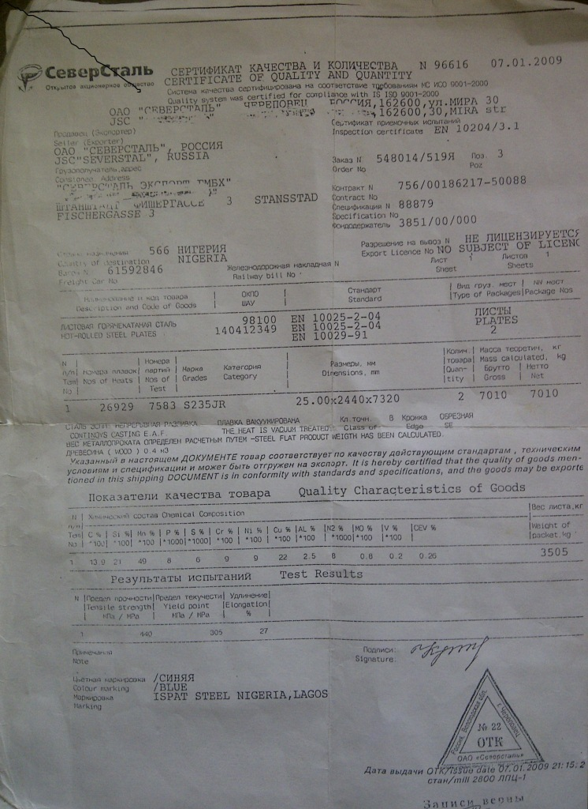

Appendix 12: The modified artificial neural networks codes

clc

formatlong

disp('Bolajis Project');

qa=input('please input source filename: ');

%qd=input('please input destination filename: ');

qc=input('please input sheet number: ');

qb='.xlsx';

filename=strcat(qa,qb);

%filename1=strcat(qd,qb);

za=xlsread(filename,qc,'B:B');zd=xlsread(filename,qc,'E:E');zg=xlsread(filename,qc,'H:H');

zb=xlsread(filename,qc,'C:C');ze=xlsread(filename,qc,'F:F');zh=xlsread(filename,qc,'I:I');

zc=xlsread(filename,qc,'D:D');zf=xlsread(filename,qc,'G:G');

za=za';zb=zb';zc=zc';zd=zd';ze=ze';zf=zf';zg=zg';zh=zh';

x=[1,25];x1=[1,25];x2=[1,25];y=[1,25];

yn=[1,25];

xn=[1,25];x_2=[1,25];x_3=[1,25];x_4=[1,25];x_5=[1,25];x_6=[1,25];xy=[1,25];x2y=[1,25];x3y=[1,25];x4y=[1,25];

xn1=[1,25];x1_2=[1,25];x1_3=[1,25];x1_4=[1,25];x1_5=[1,25];x1_6=[1,25];x1_1y=[1,25];x1_2y=[1,25];x1_3y=[1,25];x1_4y=[1,25];

xn2=[1,25];x2_2=[1,25];x2_3=[1,25];x2_4=[1,25];x2_5=[1,25];x2_6=[1,25];x2_1y=[1,25];x2_2y=[1,25];x2_3y=[1,25];x2_4y=[1,25];

j=[1,24];j1=zeros(9,4);c1=[1,25];c2=[1,25];c3=[1,25];c4=[1,25];c5=(1:25);c6=[1,25];d1=[1,25];d2=[1,25];d3=[1,25];d4=[1,25];

for i=1:5

disp(['Sample ' num2str(i)]);

for ii=1:2

if ii==1

disp('Electroplated Sample');

disp('Measured'' ''Case 1'' ''Case 2'' ''Case 3'' ''case 4');

end

if ii==2

disp('Non-Electroplated Sample');

disp('Measured'' ''Case 1'' ''Case 2'' ''Case 3'' ''case 4');

end

for iii=1:25

if ii==1

x(iii)=za(iii+(25*(i-1)))*0.1;

x1(iii)=zb(iii+(25*(i-1)))*0.1;

x2(iii)=zc(iii+(25*(i-1)))*1;

y(iii)=zd(iii+(25*(i-1)))*10000;

end

if ii==2

x(iii)=ze(iii+(25*(i-1)))*0.1;

x1(iii)=zf(iii+(25*(i-1)))*0.1;

x2(iii)=zg(iii+(25*(i-1)))*1;

y(iii)=zh(iii+(25*(i-1)))*1000;

end

end

[x_1,ind]=sort(x);

for w=1:25

k=ind(w);

xn(w)=x(k);xn1(w)=x1(k);xn2(w)=x2(k);yn(w)=y(k);

x_2(w)=xn(w)^2;x_3(w)=xn(w)^3;x_4(w)=xn(w)^4;x_5(w)=xn(w)^5;x_6(w)=xn(w)^6;

xy(w)=xn(w)*yn(w);x2y(w)=x_2(w)*yn(w);x3y(w)=x_3(w)*yn(w);x4y(w)=x_4(w)*yn(w);

x1_2(w)=xn1(w)^2;x1_3(w)=xn1(w)^3;x1_4(w)=xn1(w)^4;x1_5(w)=xn1(w)^5;x1_6(w)=xn1(w)^6;

x1_1y(w)=xn1(w)*yn(w);x1_2y(w)=x1_2(w)*yn(w);x1_3y(w)=x1_3(w)*yn(w);x1_4y(w)=x1_4(w)*yn(w);

x2_2(w)=xn2(w)^2;x2_3(w)=xn2(w)^3;x2_4(w)=xn2(w)^4;x2_5(w)=xn2(w)^5;x2_6(w)=xn2(w)^6;

x2_1y(w)=xn2(w)*yn(w);x2_2y(w)=x2_2(w)*yn(w);x2_3y(w)=x2_3(w)*yn(w);x2_4y(w)=x2_4(w)*yn(w);

end

forpk=1:24

if y(pk+1)>y(pk)

j(pk)=1;

else

j(pk)=-1;

end

end

l=0;

forpp=1:23

if j(pp+1)-j(pp)==0

else

l=l+1;

end

end

if l>2

l=2;

end

if l==0

m=sum(xn);n=sum(yn);o=sum(xy);p=sum(x_2);

m1=sum(xn1);o1=sum(x1_1y);p1=sum(x1_2);

m2=sum(xn2);o2=sum(x2_1y);p2=sum(x2_2);

u=[25 m;m p];v=[n;o];z=u\v;

u1=[25 m1;m1 p1];v1=[n;o1];z1=u1\v1;

u2=[25 m2;m2 p2];v2=[n;o2];z2=u2\v2;

j1(1,1)=z(1);j1(1,2)=z(2);

j1(2,1)=z1(1);j1(2,2)=z1(2);

j1(3,1)=z2(1);j1(3,2)=z2(2);

end

if l==1

m=sum(xn);n=sum(yn);o=sum(xy);p=sum(x_2);q=sum(x_3);r=sum(x_4);s=sum(x2y);

m1=sum(xn1);o1=sum(x1_1y);p1=sum(x1_2);q1=sum(x1_3);r1=sum(x1_4);s1=sum(x1_2y);

m2=sum(xn2);o2=sum(x2_1y);p2=sum(x2_2);q2=sum(x2_3);r2=sum(x2_4);s2=sum(x2_2y);

u=[25 m p;m p q;p q r];v=[n;o;s];z=u\v;

u1=[25 m1 p1;m1 p1 q1;p1 q1 r1];v1=[n;o1;s1];z1=u1\v1;

u2=[25 m2 p2;m2 p2 q2;p2 q2 r2];v2=[n;o2;s2];z2=u2\v2;

j1(4,1)=z(1);j1(4,2)=z(2);j1(4,3)=z(3);

j1(5,1)=z1(1);j1(5,2)=z1(2);j1(5,3)=z1(3);

j1(6,1)=z2(1);j1(6,2)=z2(2);j1(6,3)=z2(3);

end

if l==2

m=sum(xn);n=sum(yn);o=sum(xy);p=sum(x_2);q=sum(x_3);r=sum(x_4);t=sum(x_5);bb=sum(x_6);c=sum(x3y);s=sum(x2y);

m1=sum(xn1);o1=sum(x1_1y);p1=sum(x1_2);q1=sum(x1_3);r1=sum(x1_4);t1=sum(x1_5);bb1=sum(x1_6);c1=sum(x1_3y);s1=sum(x1_2y);

m2=sum(xn2);o2=sum(x2_1y);p2=sum(x2_2);q2=sum(x2_3);r2=sum(x2_4);t2=sum(x2_5);bb2=sum(x2_6);c2=sum(x2_3y);s2=sum(x2_2y);

u=[25 m p q;m p q r;p q r t;q r t bb];v=[n;o;s;c];z=u\v;

u1=[25 m1 p1 q1;m1 p1 q1 r1;p1 q1 r1 t1;q1 r1 t1 bb1];v1=[n;o1;s1;c1];z1=u1\v1;

u2=[25 m2 p2 q2;m2 p2 q2 r2;p2 q2 r2 t2;q2 r2 t2 bb2];v2=[n;o2;s2;c2];z2=u2\v2;

j1(7,1)=z(1);j1(7,2)=z(2);j1(7,3)=z(3);j1(7,4)=z(4);

j1(8,1)=z1(1);j1(8,2)=z1(2);j1(8,3)=z1(3);j1(8,4)=z1(4);

j1(9,1)=z2(1);j1(9,2)=z2(2);j1(9,3)=z2(3);j1(9,4)=z2(4);

end

forlk=1:25

ma=xn(lk);mb=xn1(lk);mc=xn2(lk);

jj=(j1((3*l)+1,1)+(j1((3*l)+1,2)*(ma))+(j1((3*l)+1,3)*((ma)^2))+(j1((3*l)+1,4)*((ma)^3)));

jk=(j1((3*l)+2,1)+(j1((3*l)+2,2)*(mb))+(j1((3*l)+2,3)*((mb)^2))+(j1((3*l)+2,4)*((mb)^3)));

jl=(j1((3*l)+3,1)+(j1((3*l)+3,2)*(mc))+(j1((3*l)+3,3)*((mc)^2))+(j1((3*l)+3,4)*((mc)^3)));

k2=((jj+jk+jl)/3)*0.0001;%considering all the three inputs

k3=((jj+jk)/2)*0.0001;%considering the first two inputs

k4=((jj+jl)/2)*0.0001;%cinsidering the first and the last input

k5=((jk+jl)/2)*0.0001;%considering the last two inputs

yreal=yn(lk)*0.0001;

%f1=xn(lk)/10;f2=xn1(lk)*100;f3=xn2(lk)/10;f4=xn3(lk);f5=xn4(lk)*10;

c1(lk)=yreal;c2(lk)=k2;c3(lk)=k3;c4(lk)=k4;c6(lk)=k5;

d1(lk)=c1(lk)-c2(lk);d2(lk)=c1(lk)-c3(lk);d3(lk)=c1(lk)-c4(lk);d4(lk)=c1(lk)-c6(lk);

formatshort

disp([yreal k2 k3 k4 k5]);

%disp(j1);

end

disp(j1);

figure(i)

subplot(2,1,ii);

plot(c5,c1,c5,c2,c5,c3,c5,c4,c5,c6);

h=legend(' Measured',' case 1',' case 2',' case 3',' case 4',1);

set(h,'interpreter','none');

xlabel('days');ylabel('CPR(mm/y)');

if ii==1

title(['Electroplated Sample ' num2str(i)]);

end

if ii==2

title(['Non-Electroplated Sample ' num2str(i)]);

end

end

end

da=sum(d1)*4;db=sum(d2)*4;dc=sum(d3)*4;dd=sum(d4)*4;

figure(11)

plot(c5,d1,c5,d2,c5,d3,c5,d4);

h=legend(' case 1',' case 2',' case 3',' case 4',1);

set(h,'interpreter','none');

xlabel('days');ylabel('error(mm/yr)');title('error plot versus days');

disp('errors');

disp([' case 1'' ''case 2'' ''case 3'' ''case 4']);

disp([d1' d2' d3' d4']);

disp('percentage errors');

disp('case 1');

disp(da);

disp('case 2');

disp(db);

disp('case 3');

disp(dc);

disp('case 4');

disp(dd);

# REFERENCES

Abd El-Lateef, M. H., Abbasov, V. M., Aliyeva, L. I., Ismayilov, T. A. 2012. Corrosion Protection of Steel Pipelines Against CO2 Corrosion-A Review. Chemistry Journal, 2(2), 52-63.

Akron Steel Training Company. 1987. Modern Steels and their properties. Ohio: Metal Treating Institute.

Beavers, J. A., Thompson, N. G., CC Technologies.2006. External Corrosion of Oil and Natural Gas pipelines. Ohio. ASM International.

Ekott, E. J., Akpabio, E. J., Etukudo, U. I. 2012.Cathodic Protection of Buried Steel Oil Pipelines in Niger Delta. Environmental Research Journal, 6(4), 304-307.

Emami, M. R. S. 2011. Mathematical modelling of corrosion phenomenon in pipelines.The journal of Mathematics and Computer Science, 3(2), 202-211.

http://www.mathworks.com/products/neuralnet

Kennedy, J. L. 1993. Oil and gas pipeline fundamentals. 2nd ed. PennWell Books

Lee J. and Kim T. 2009 “A messy Genetic Algorithm and its application to an approximate optimization of an occupant safety system” journal of Automobile Engineering, 757-758

Malik, A. U., Andijani, I. 2005. Corrosion Behaviour of Materials in RO water containing 250-350 PPM Chloride, International Desalination Association (IDA) World Congress Conference, Singapore 1-13.

Malik, A. U., Ahmad, S., Andijani, I., Al-Muaili, F., Prakash, T. L., O’Hara, J. 1999. Corrosion Protection Evaluation of some Organic Coatings in Water Transmission Lines (Report No.TR 3804/APP 95009). Kingdom of Saudi Arabia: Saline Water Conversion Corporation.

Monyei, C. G., Aiyelari, T., Oluwatunde, S. 2013. Neural Network Modeling of Electronic Waste Deposits in Nigeria: Subtle Prod for quick Intervention’ in proceedings of the iSTEAMS Research. Nexus Multidisciplinary Conference, Series 4 Volume 1, 181-188.

Oyewole, A., 2011. Characterization of External Induced Corrosion Degradation of Ajaokuta-Abuja Gas Pipeline System, Nigeria. International Journal of Engineering and Technology, 3(11), 8061-8068

Sadiku-Agboola, O., Sadiku, E. R., Biotidara O. F. 2012. The properties and the effect of operating parameters on nickel plating (review). International Journal of the Physical Sciences, 7(3), 349-360

Samimi, A. 2013.Causes of Increased Corrosion in Oil and Gas Pipelines in the Middle East. International Journal of Basic and Applied Sciences, 572-577.

Shen, W., Developing a Reliable and Efficient Corrosion Resistance Characterization Technique for Magnesium Alloys Used in Automotive and Other Manufacturing Industries.Faculty Research Fellowship.

Yahaya, N., Noor, N. M., Othman, S. R., Sing, L. K., Din, M. M. 2011. New Technique for Studying Soil-Corrosion of Underground Pipeline. Journal of Applied Sciences, 11(9), 1510-1518.